第二章 CPU调度(2.2)

知识点：

缩写全称：
https://chatgpt.com/g/g-p-6a4147b6a8088191bef869eb87bbe5c0-cao-zuo-xi-tong/c/6a5b68f9-d62c-83e8-8198-1366cc7927c0

线程切换开销：
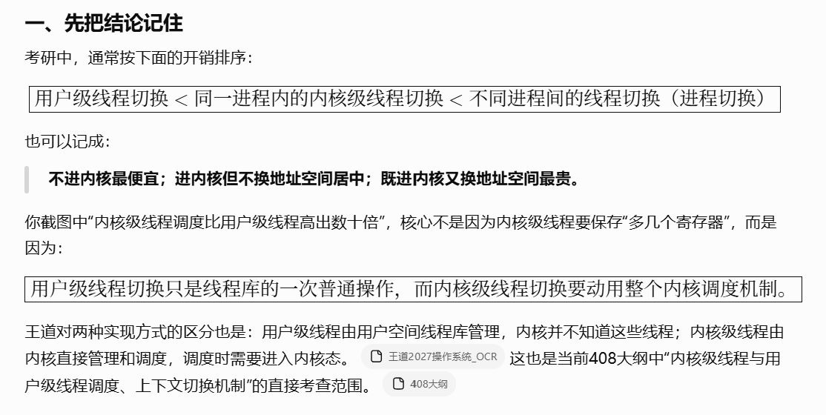
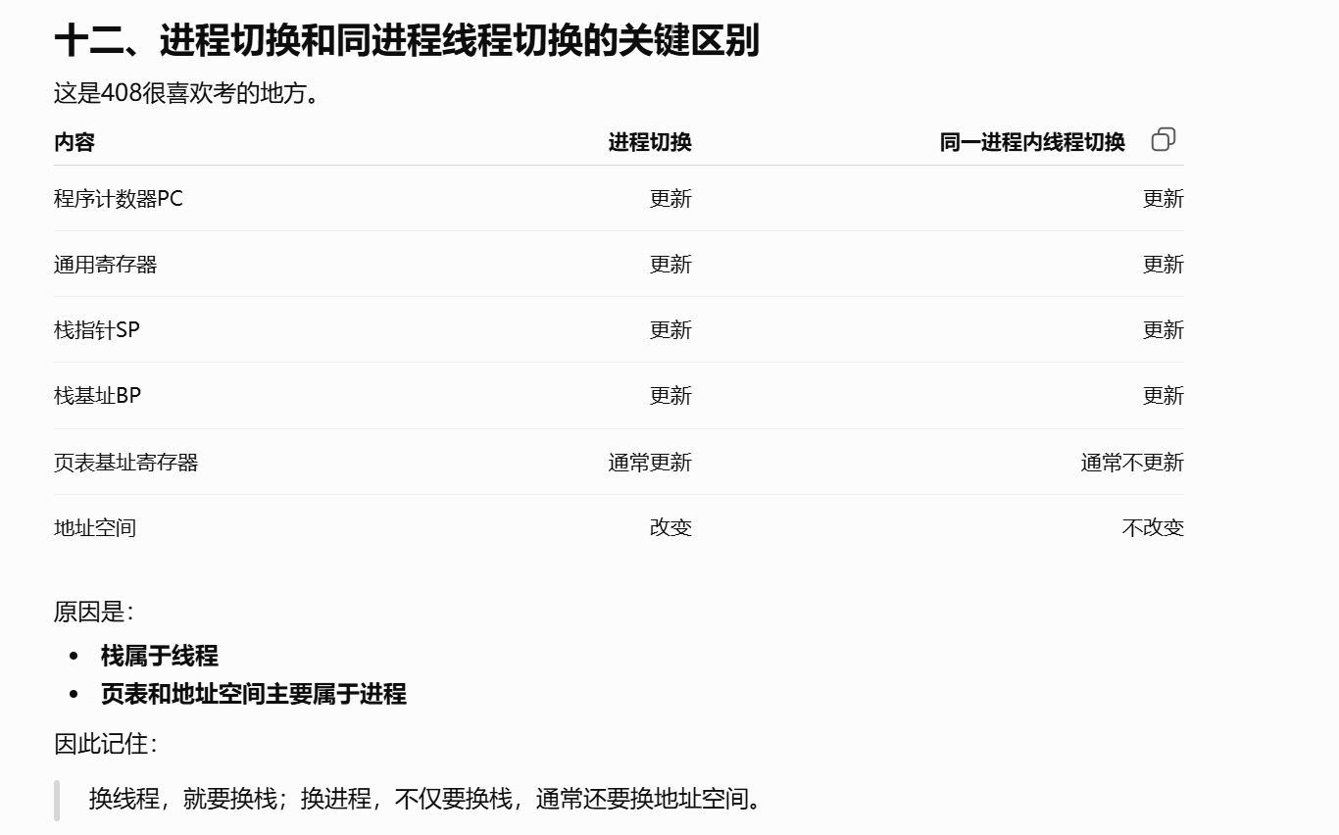
https://chatgpt.com/g/g-p-6a4147b6a8088191bef869eb87bbe5c0-cao-zuo-xi-tong/c/6a5a23c6-f8c4-83ee-8592-f57845297c8b

CPU调度衡量指标：
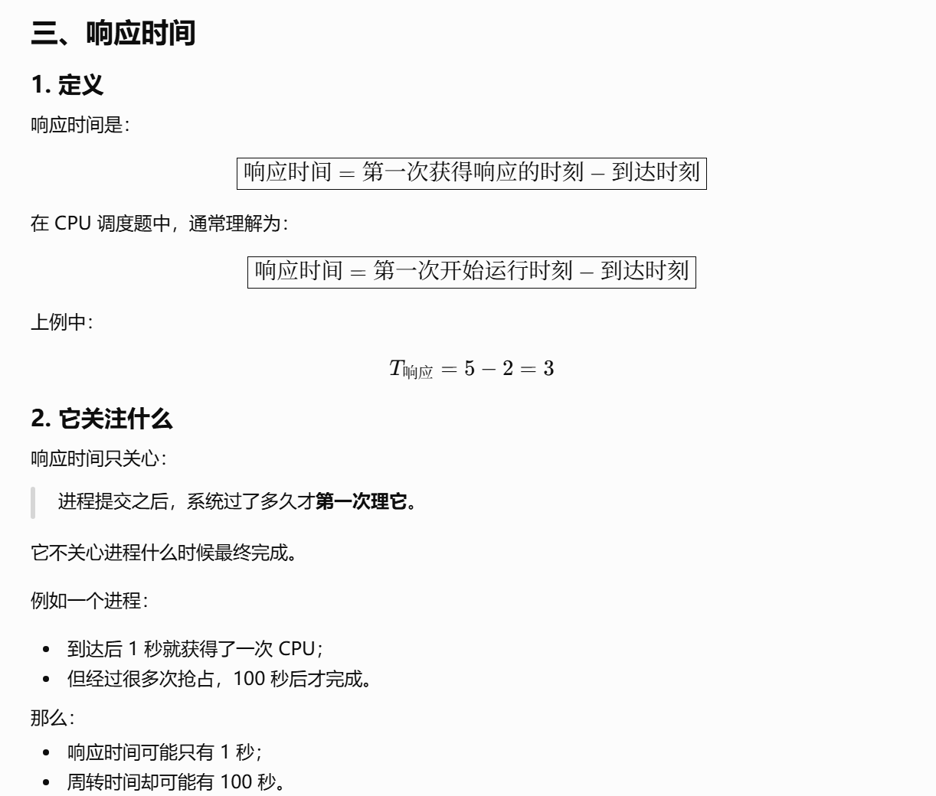
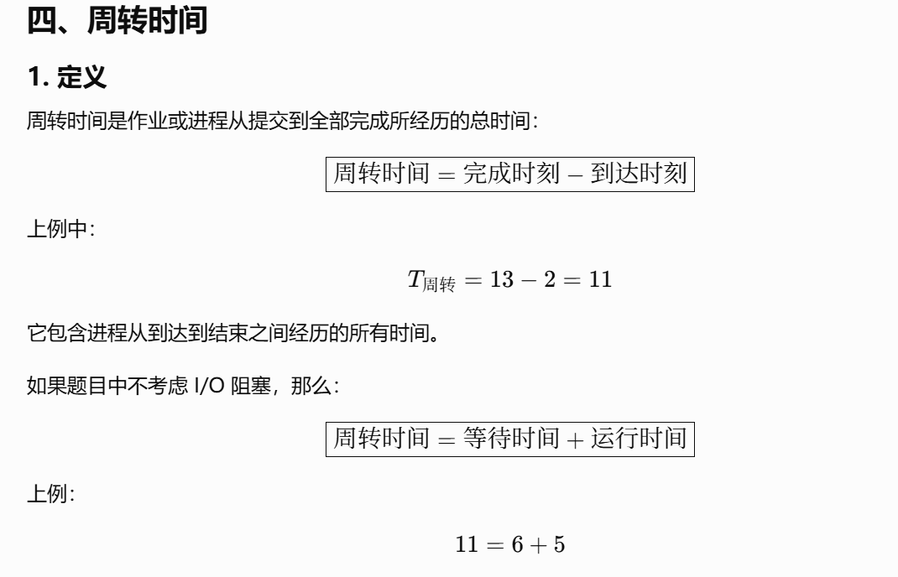
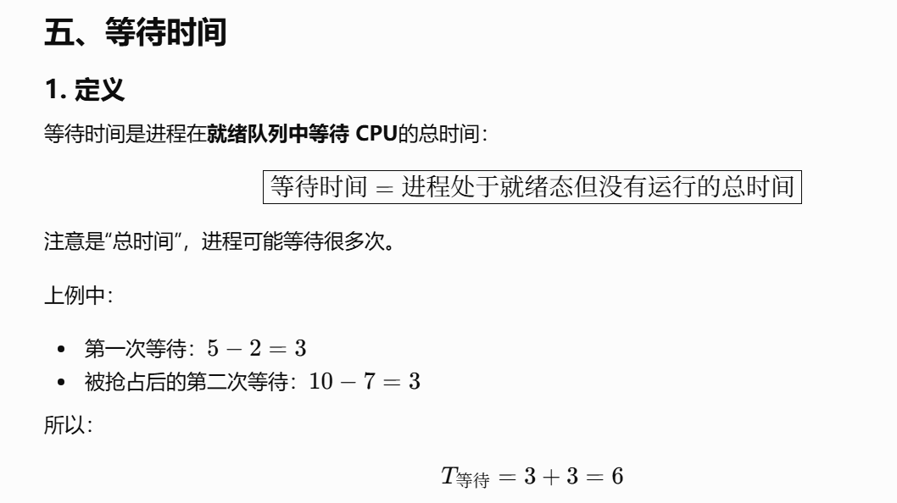
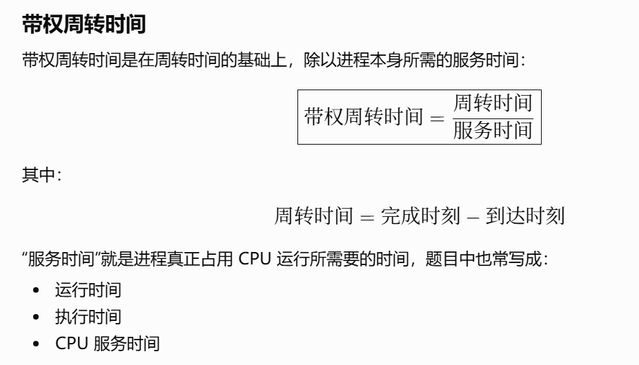

https://chatgpt.com/g/g-p-6a4147b6a8088191bef869eb87bbe5c0-cao-zuo-xi-tong/c/6a5b6ae5-03a4-83e8-80e5-d5d12650f4b7

CPU调度算法归纳总结：
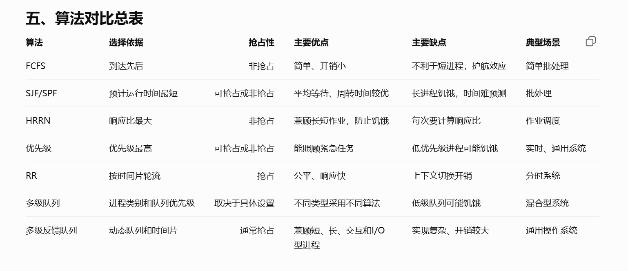
https://chatgpt.com/g/g-p-6a4147b6a8088191bef869eb87bbe5c0-cao-zuo-xi-tong/c/6a5c7c63-3ef8-83ee-8ff3-830fbc9ec1f2
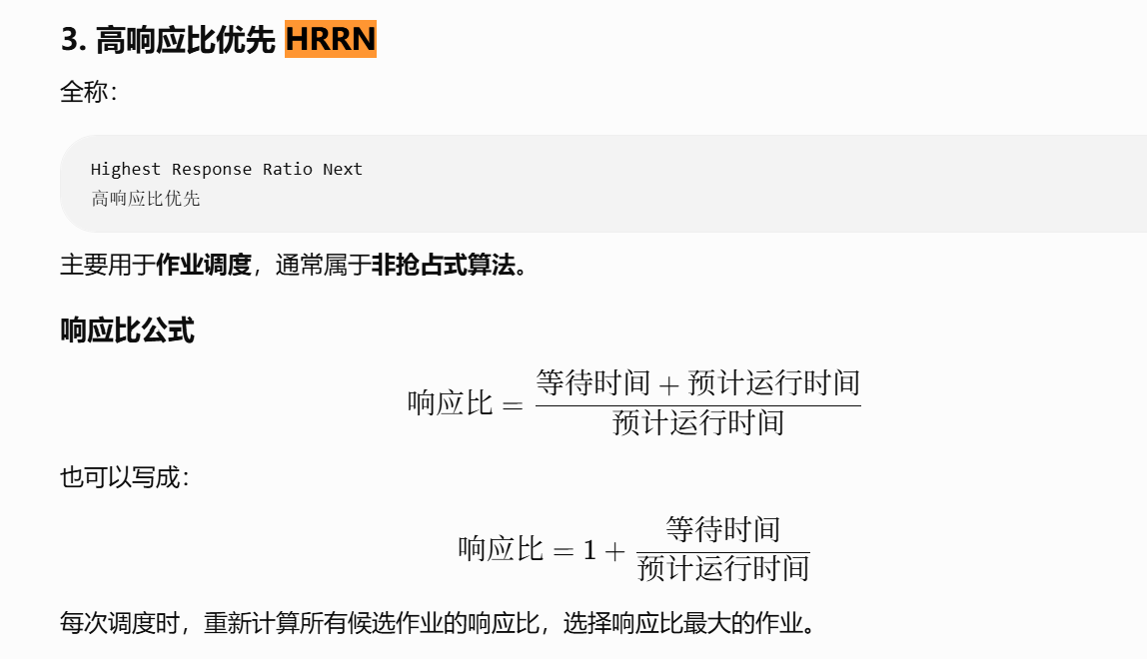

作业调度流程：
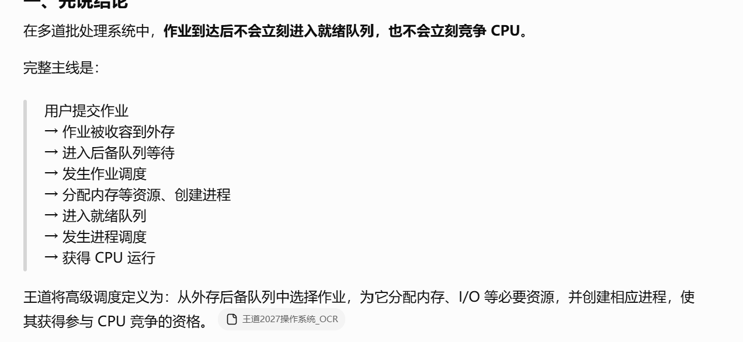
https://chatgpt.com/g/g-p-6a4147b6a8088191bef869eb87bbe5c0-cao-zuo-xi-tong/c/6a5e0be9-faac-83ee-83be-832b964656e8

概念：

负载平衡：

进程和作业的区别：
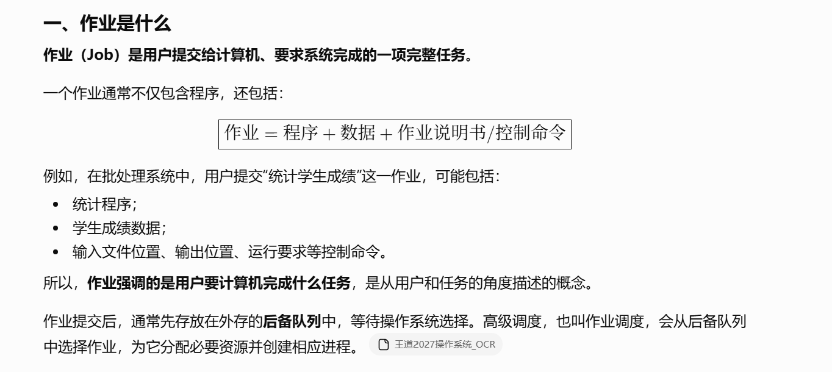
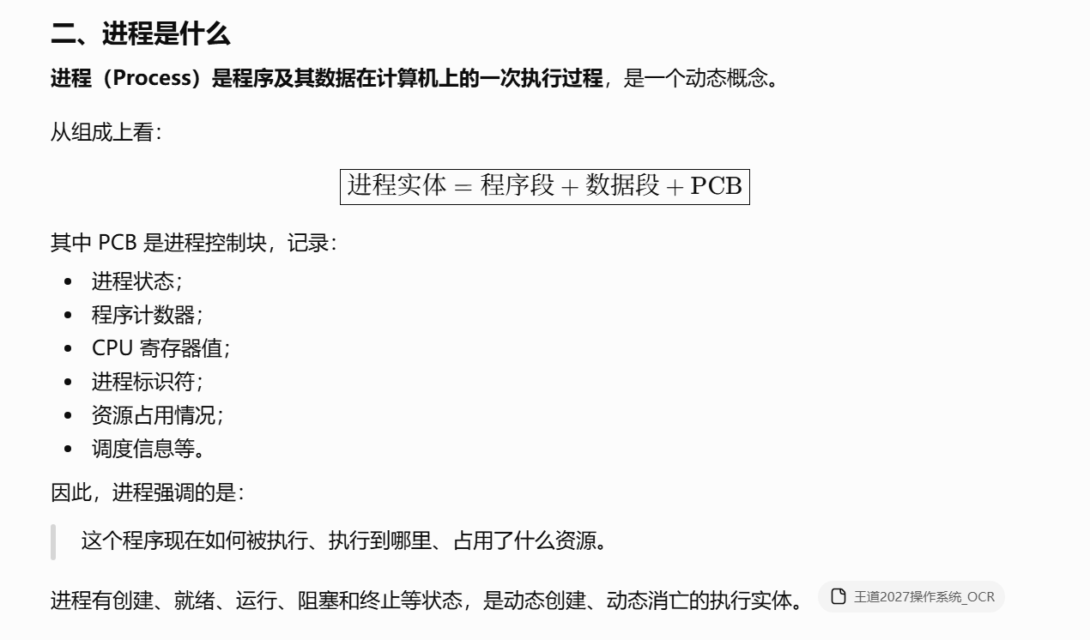
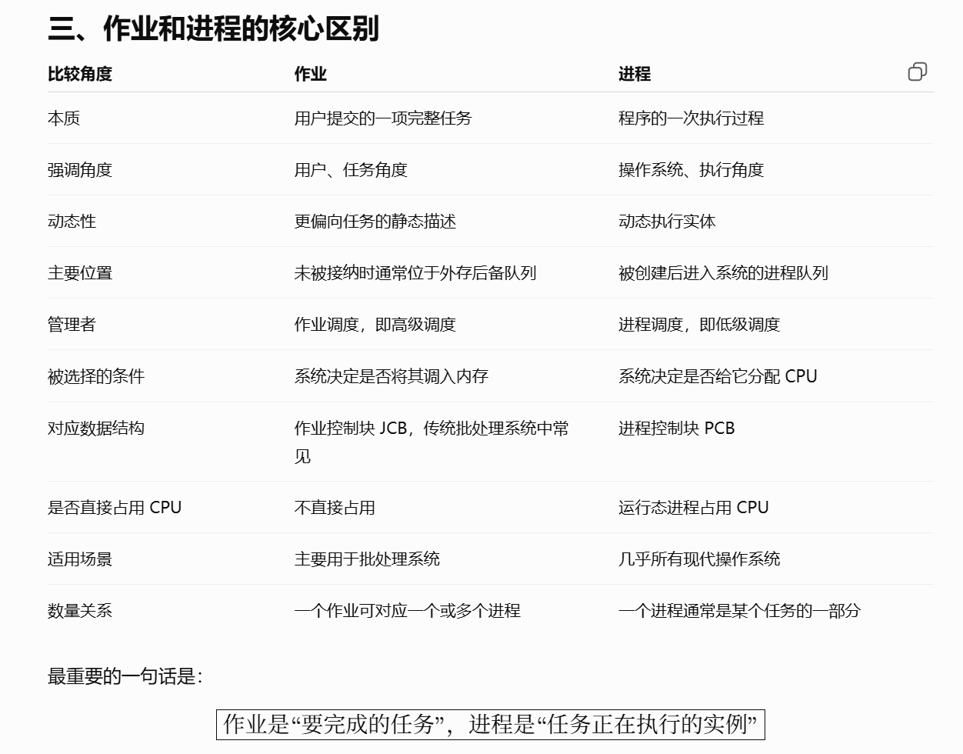
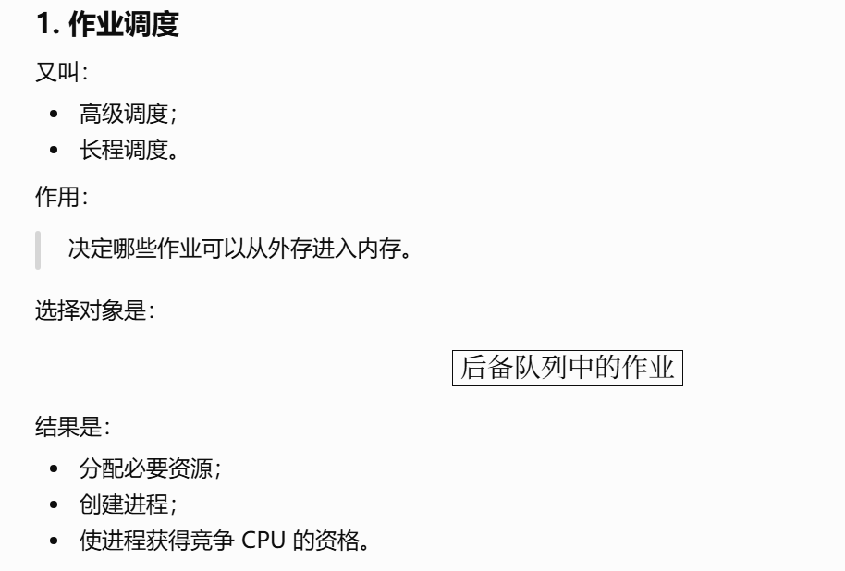
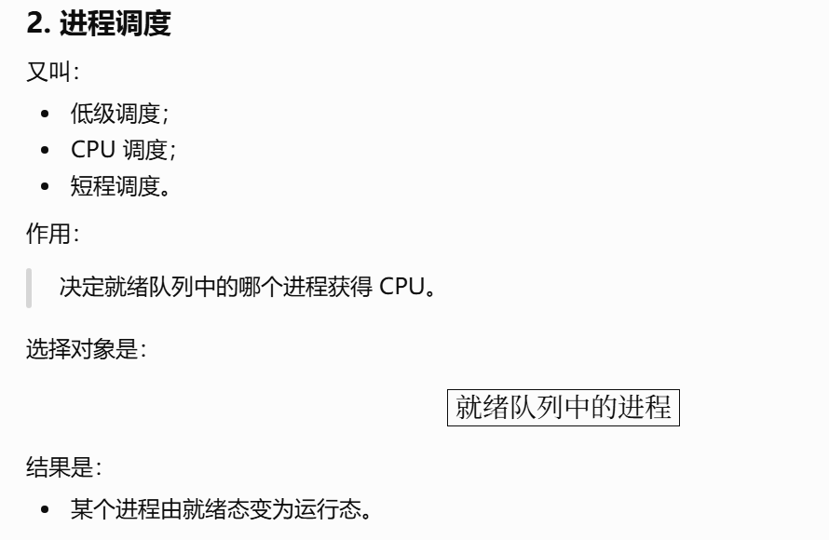

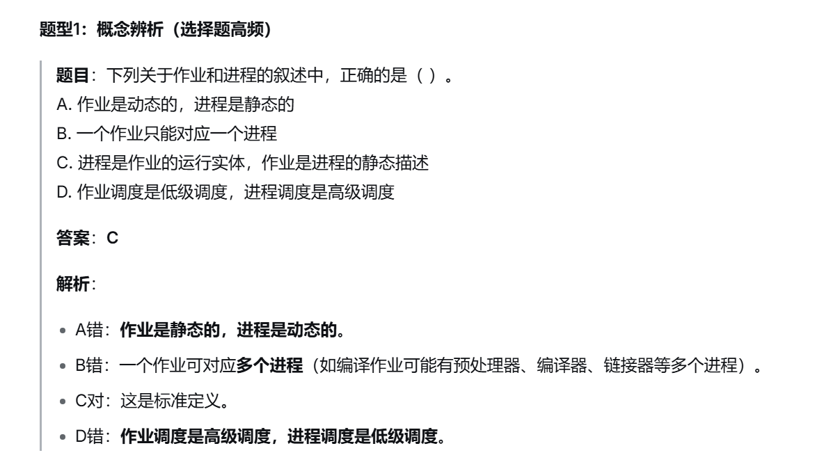
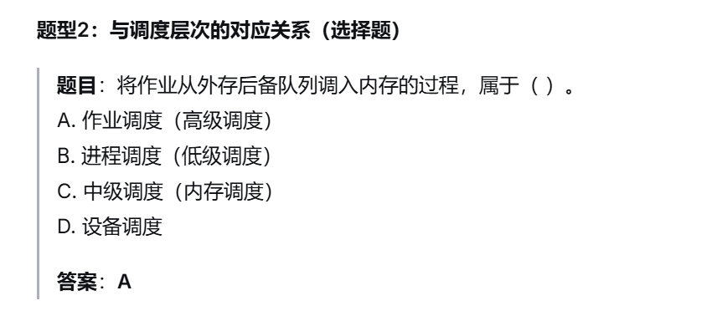
https://chatgpt.com/g/g-p-6a4147b6a8088191bef869eb87bbe5c0-cao-zuo-xi-tong/c/6a5c88d5-e328-83ee-9d65-2b8601c8b645

页表基地址寄存器：
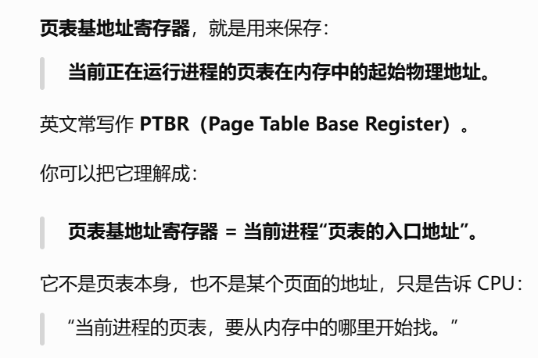
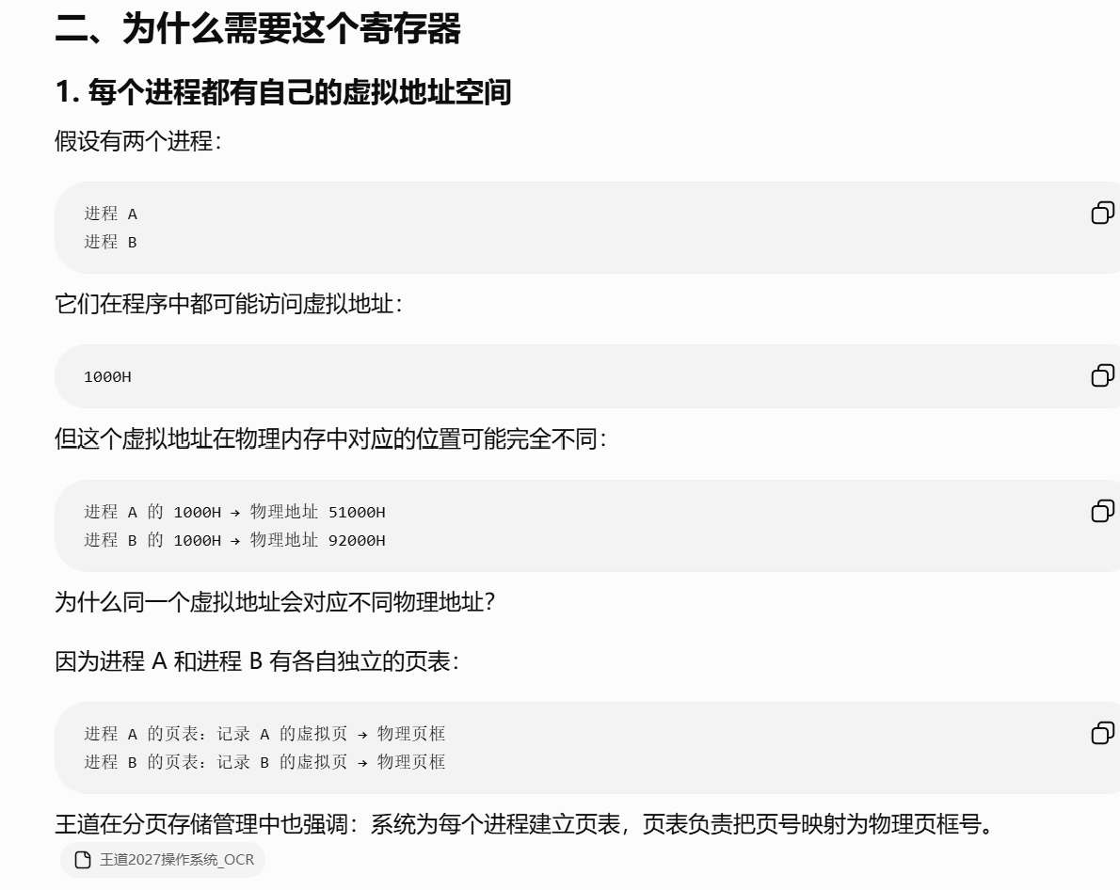
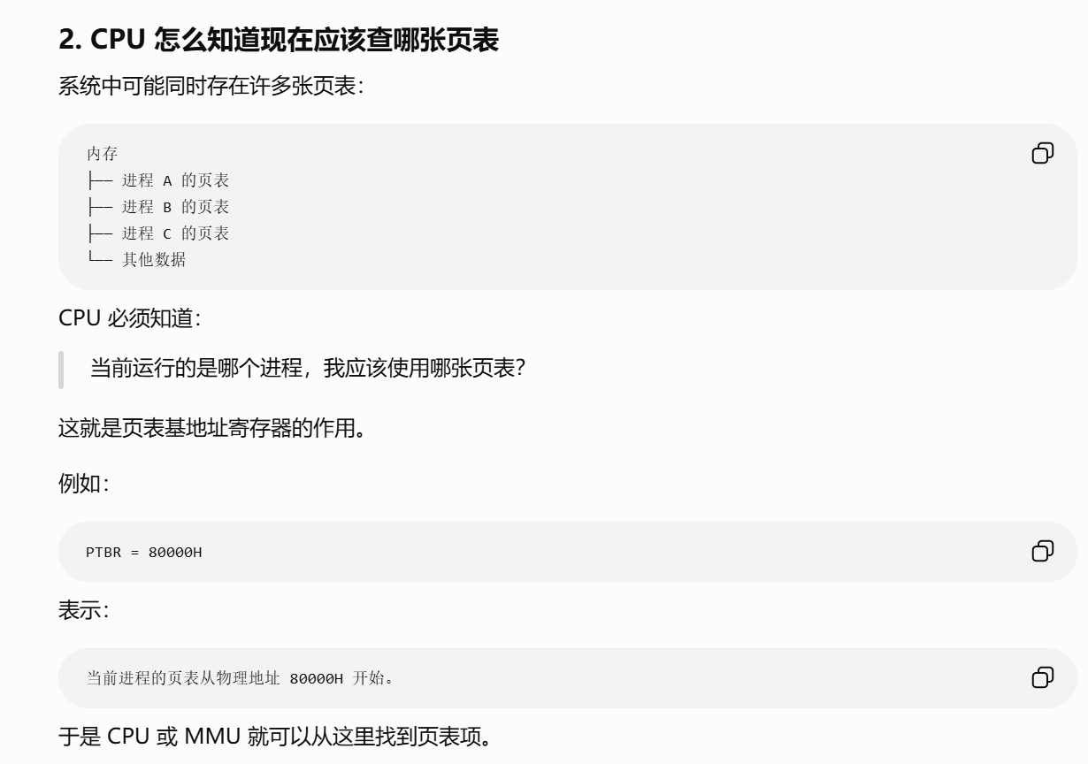
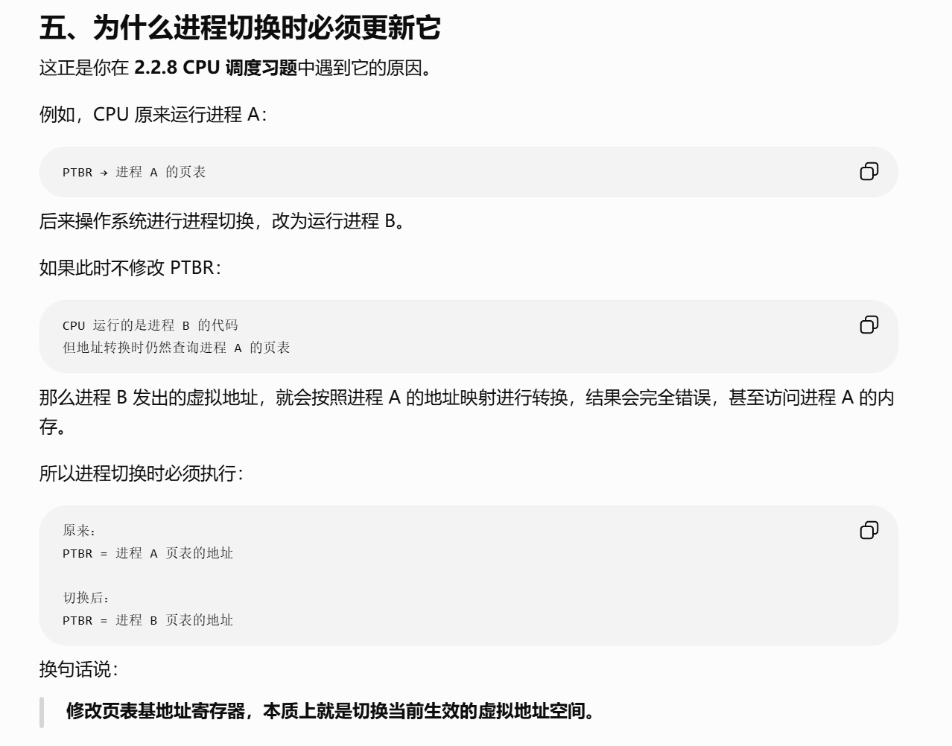
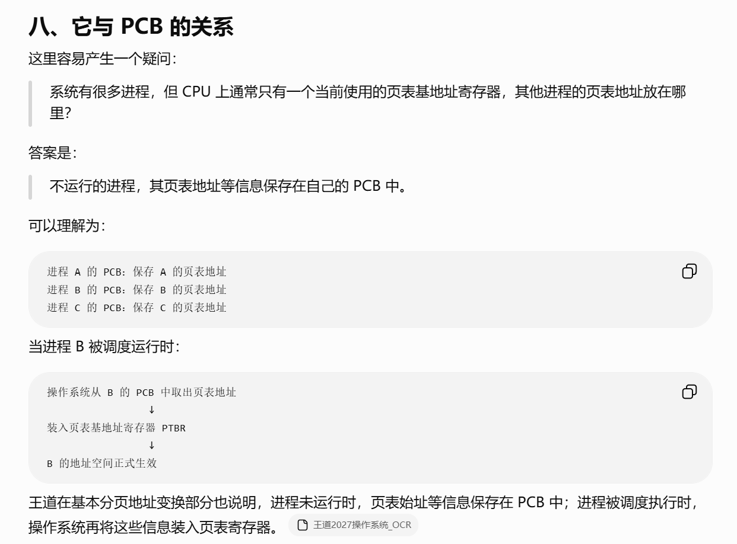
https://chatgpt.com/g/g-p-6a4147b6a8088191bef869eb87bbe5c0-cao-zuo-xi-tong/c/6a5e13f9-9688-83e8-8923-0c3b278b7598

栈基址寄存器：
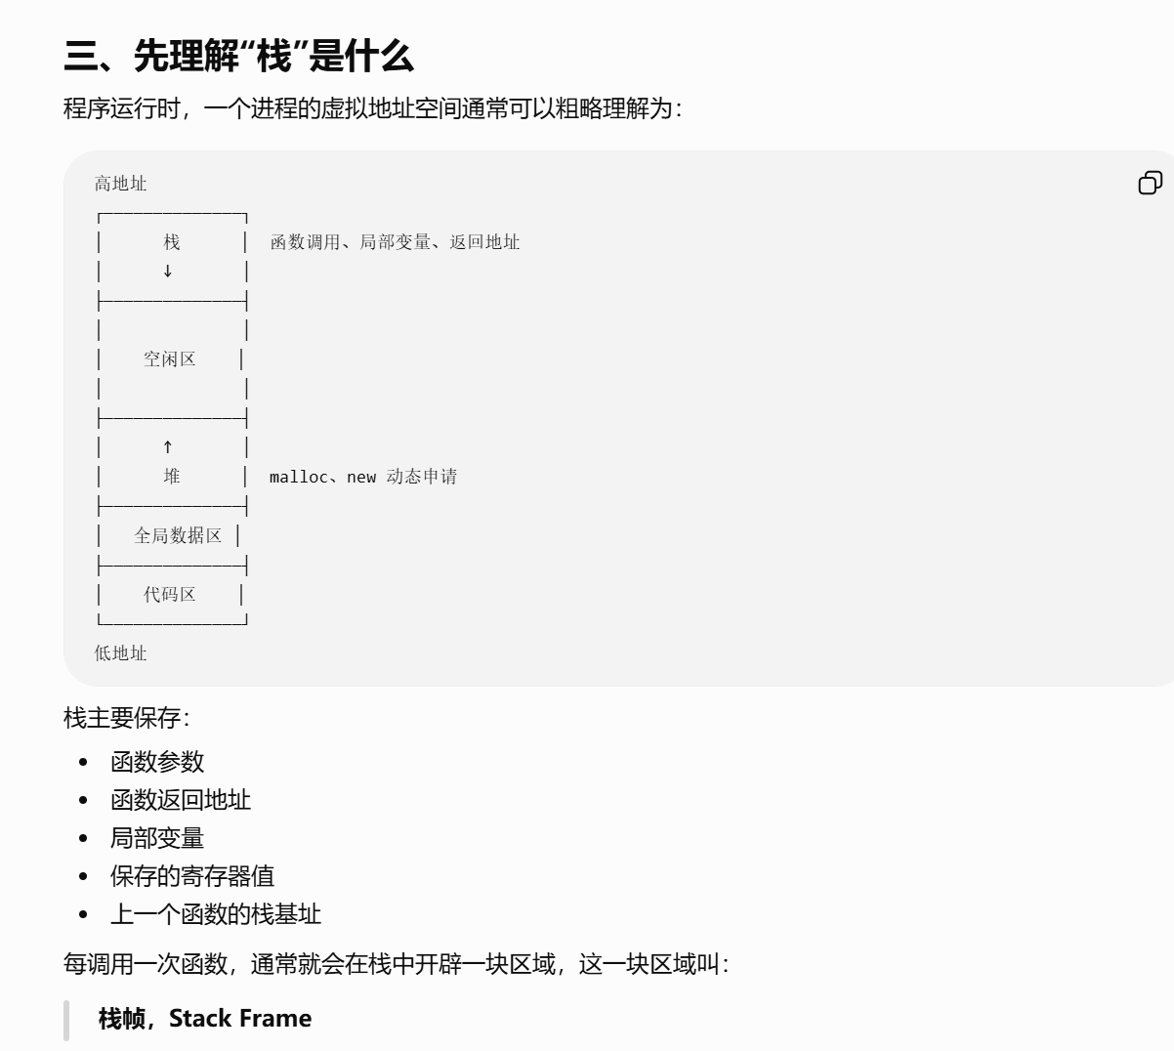

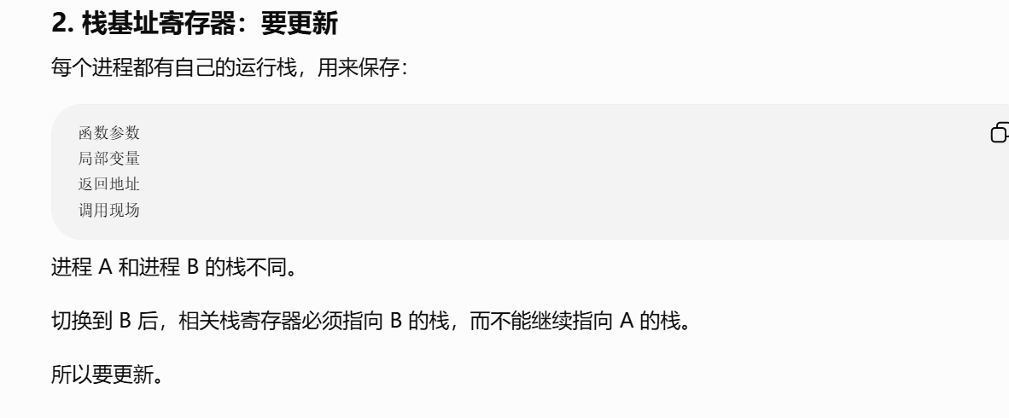
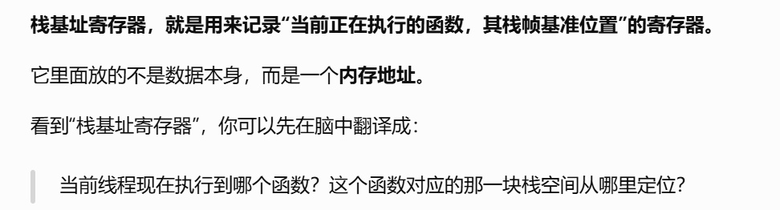
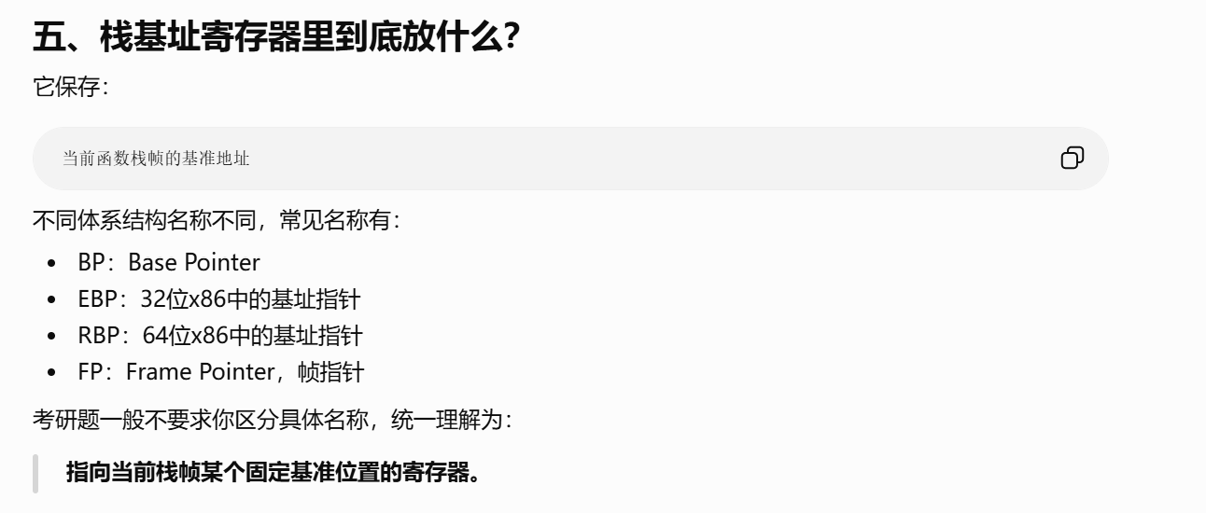
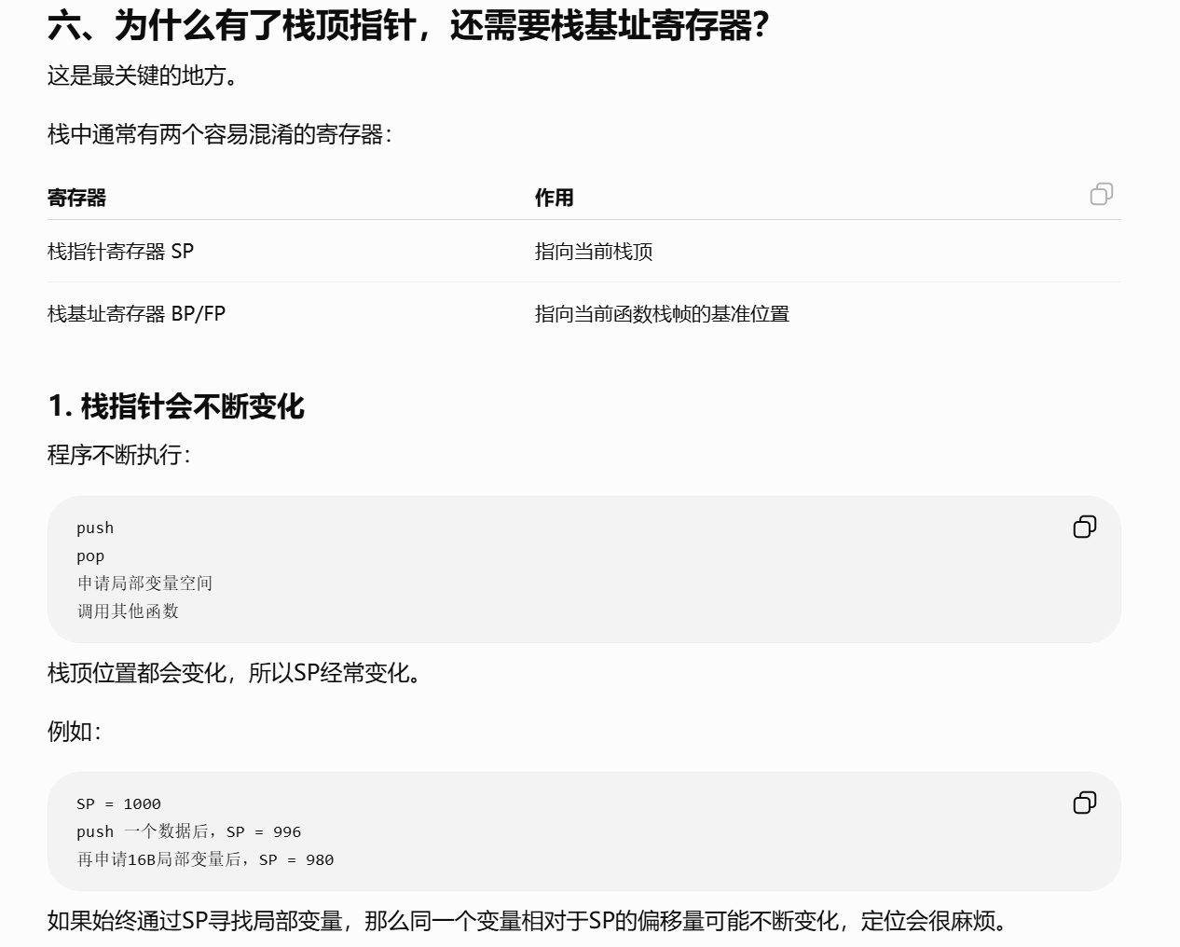
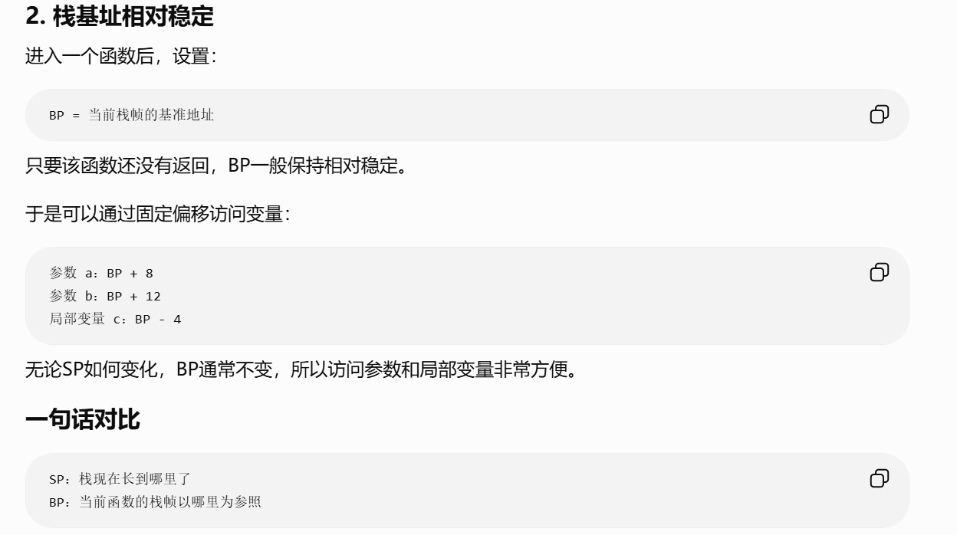
https://chatgpt.com/g/g-p-6a4147b6a8088191bef869eb87bbe5c0-cao-zuo-xi-tong/c/6a5e18c3-6a94-83e8-83ca-6a323a441b0b?tab=sources

通用寄存器：
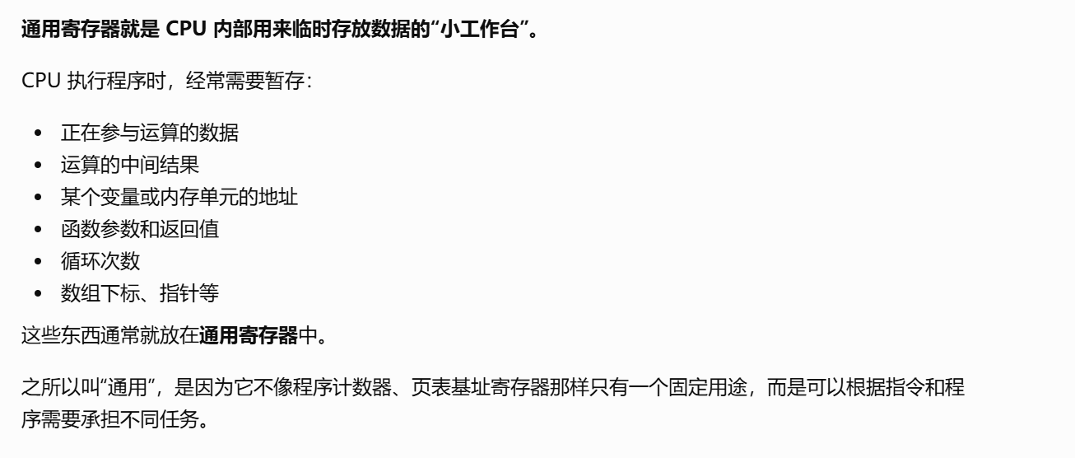
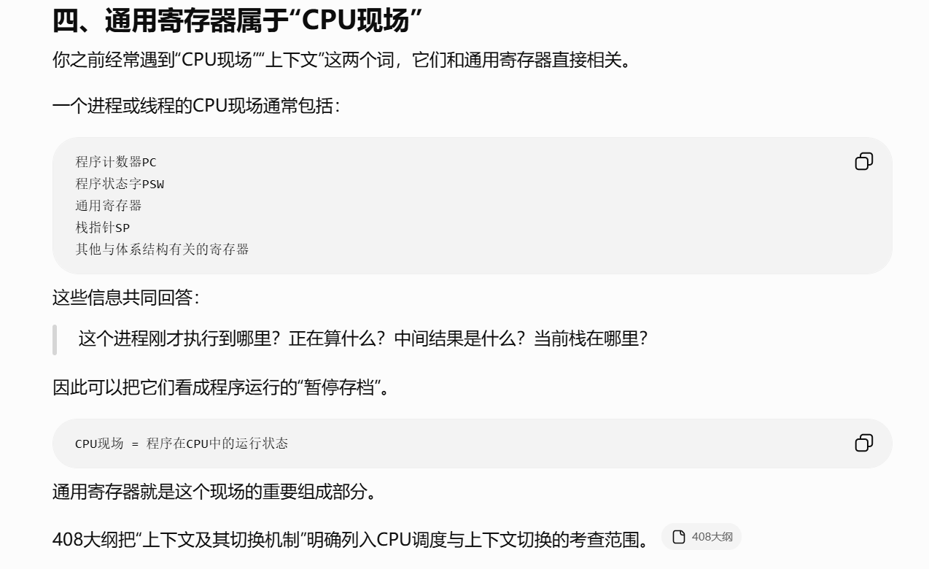
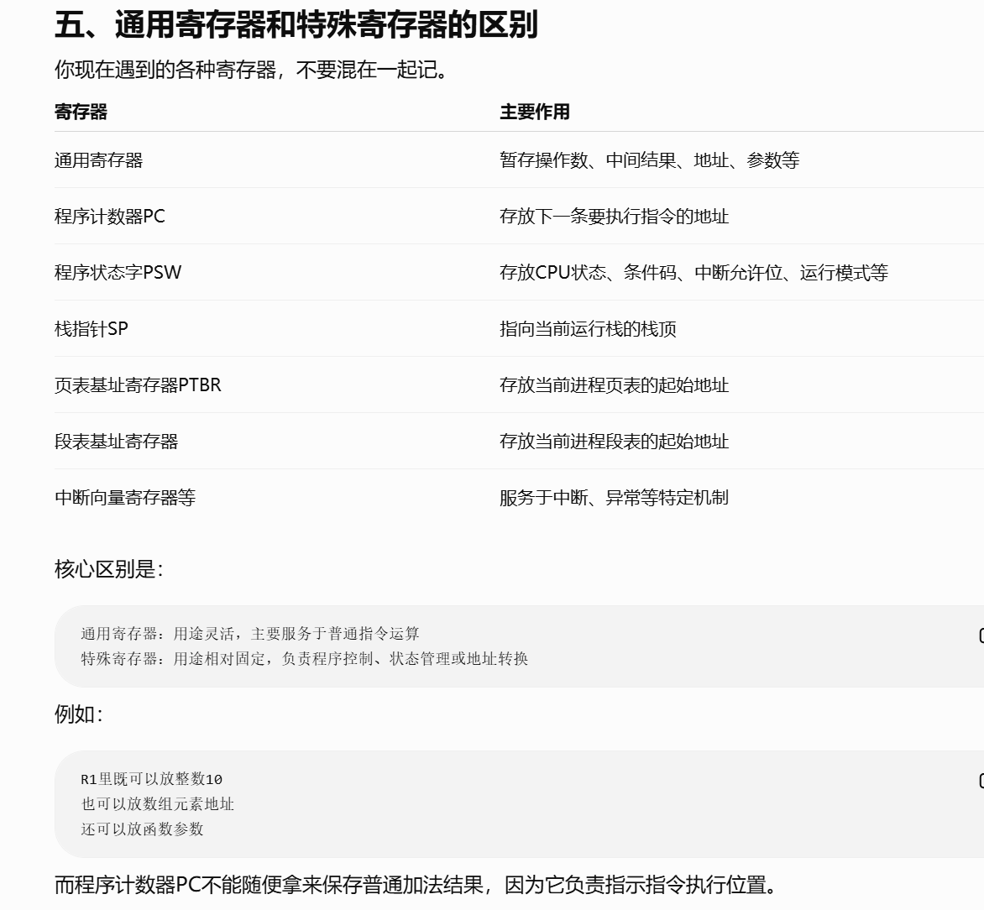
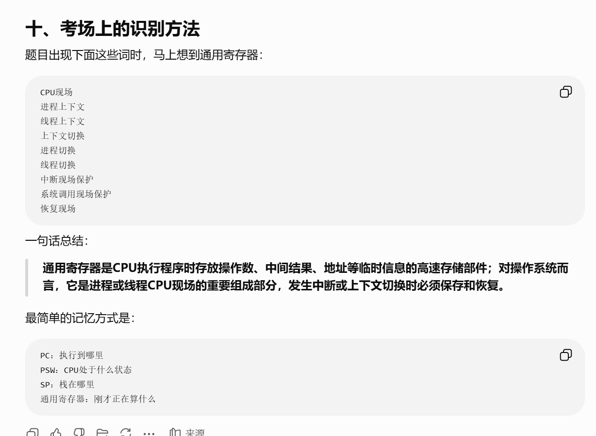
https://chatgpt.com/g/g-p-6a4147b6a8088191bef869eb87bbe5c0-cao-zuo-xi-tong/c/6a5e2981-e74c-83ee-8930-412cdf0858f3

题：

题1：
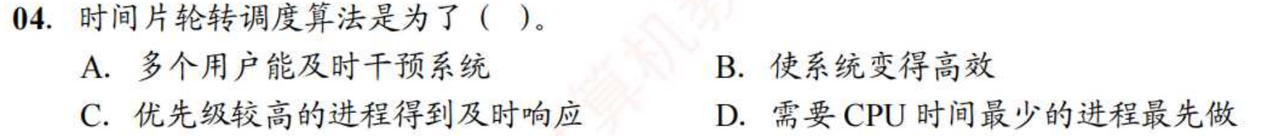
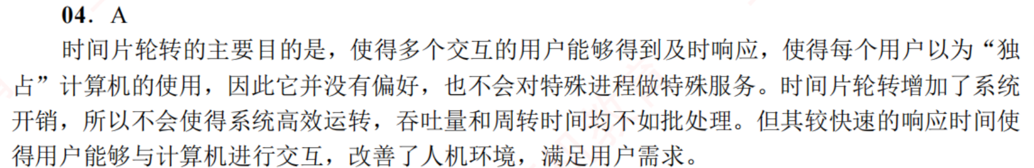

题2：
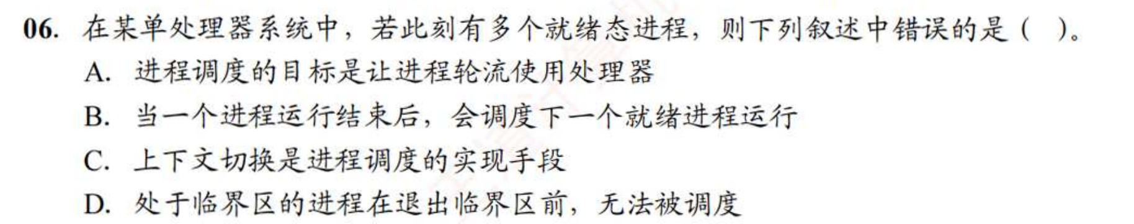
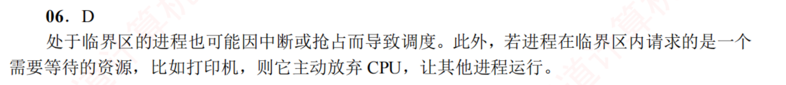
https://chatgpt.com/g/g-p-6a4147b6a8088191bef869eb87bbe5c0-cao-zuo-xi-tong/c/6a5a2d8c-a320-83ee-ad15-a27ab481174c

题3：
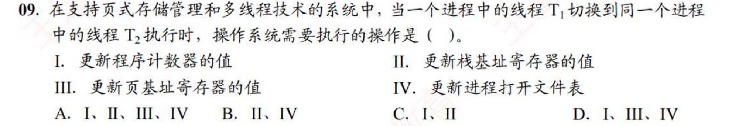
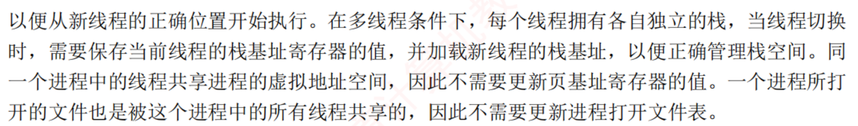
https://chatgpt.com/g/g-p-6a4147b6a8088191bef869eb87bbe5c0-cao-zuo-xi-tong/c/6a5a2deb-43ec-83ee-a2f2-eb63cafb3457

题4：
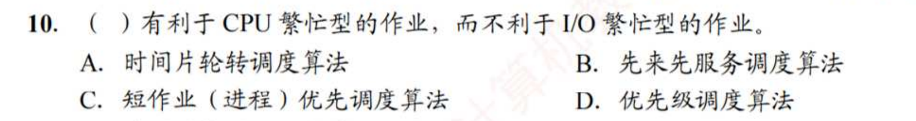
https://chatgpt.com/g/g-p-6a4147b6a8088191bef869eb87bbe5c0-cao-zuo-xi-tong/c/6a5c7b14-38bc-83ee-b9b4-7860cf986d76

题5：
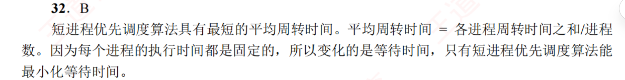

题6：
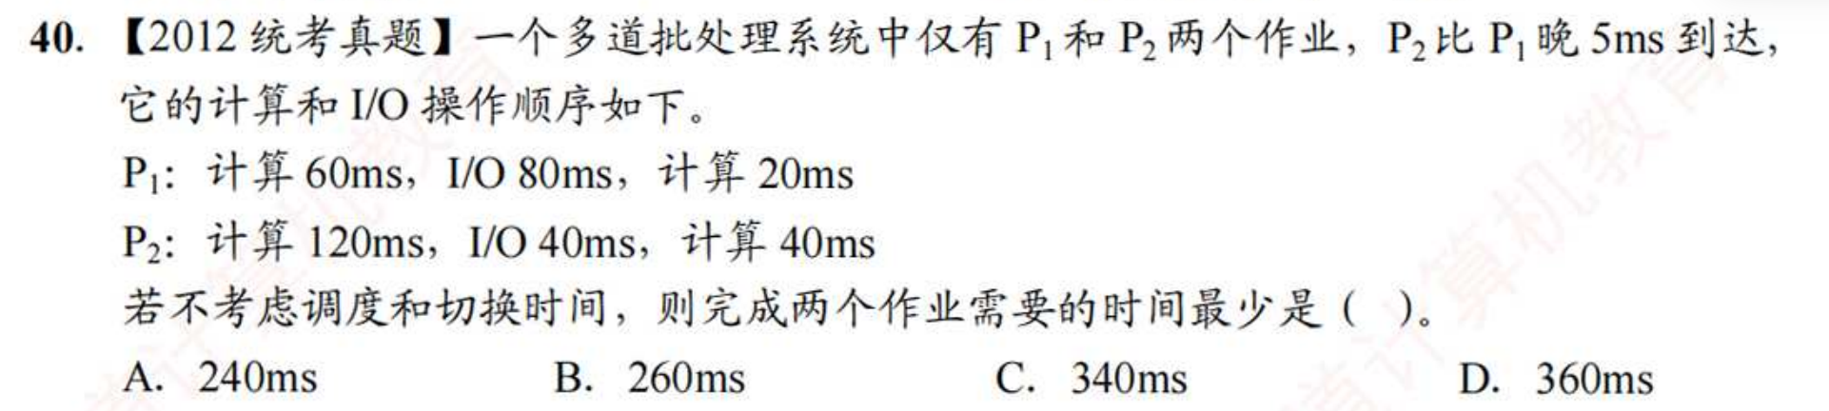
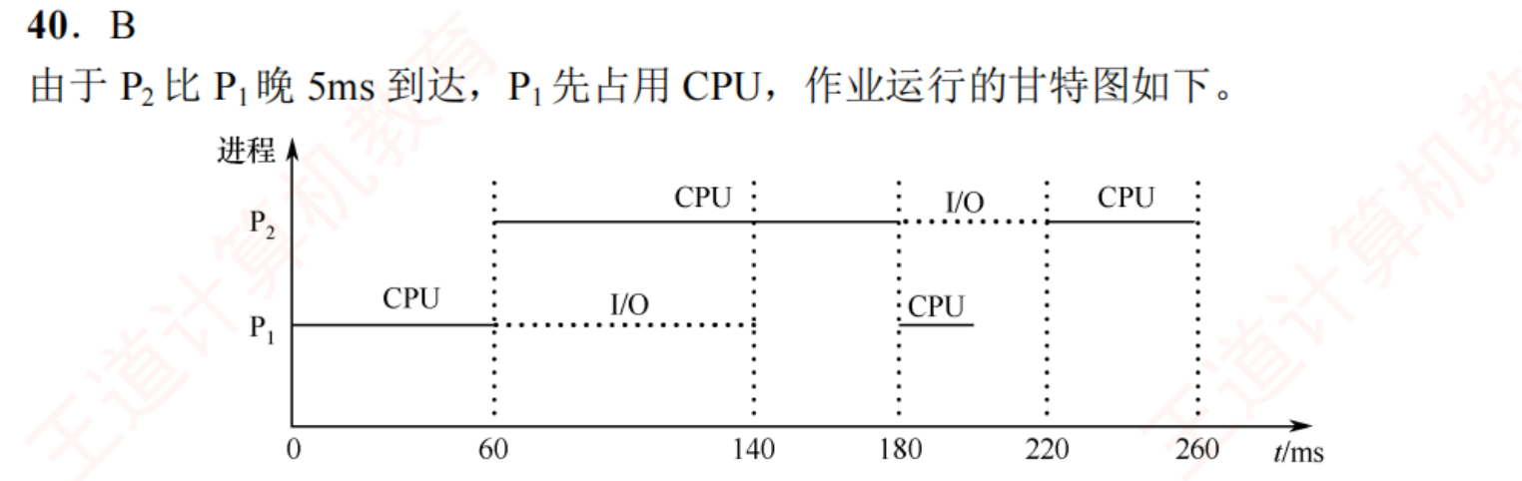
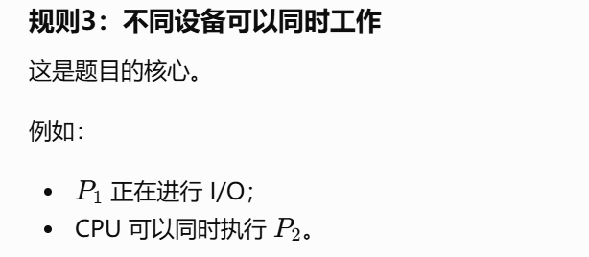

题7：
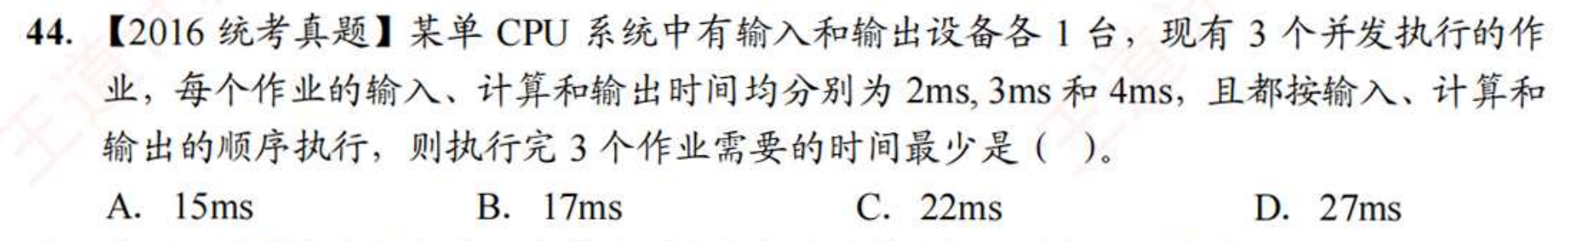
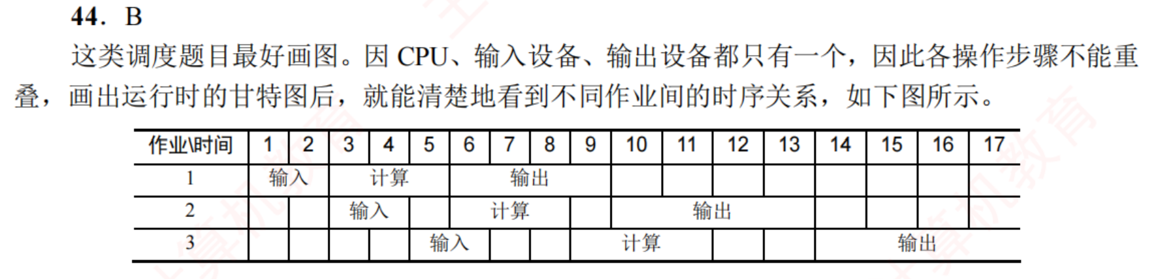
关键是画图
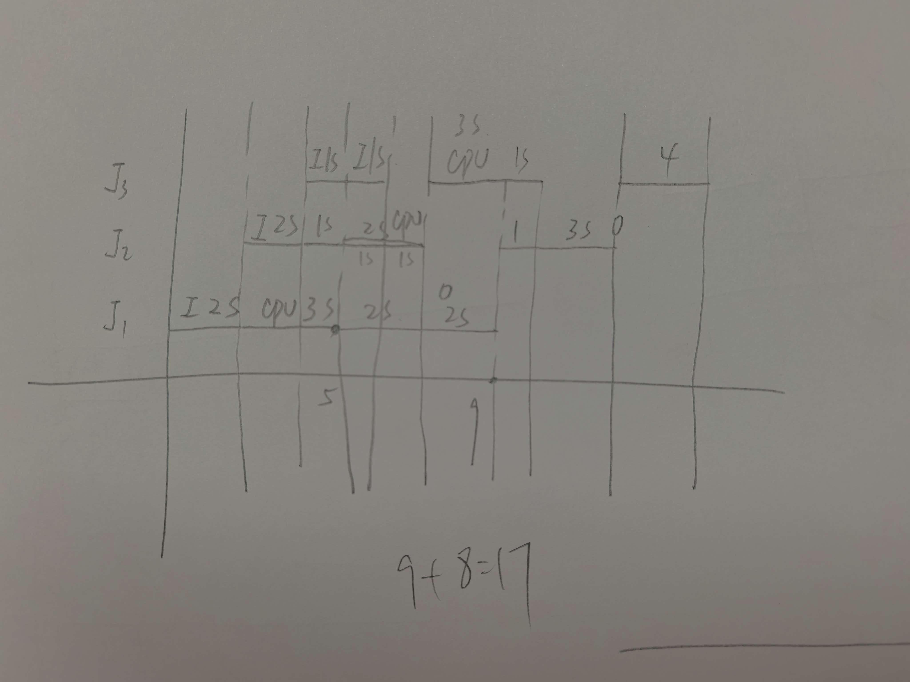
https://chatgpt.com/g/g-p-6a4147b6a8088191bef869eb87bbe5c0-cao-zuo-xi-tong/c/6a5e1e7d-4b24-83ee-8552-c65f396d1ff5

题8：
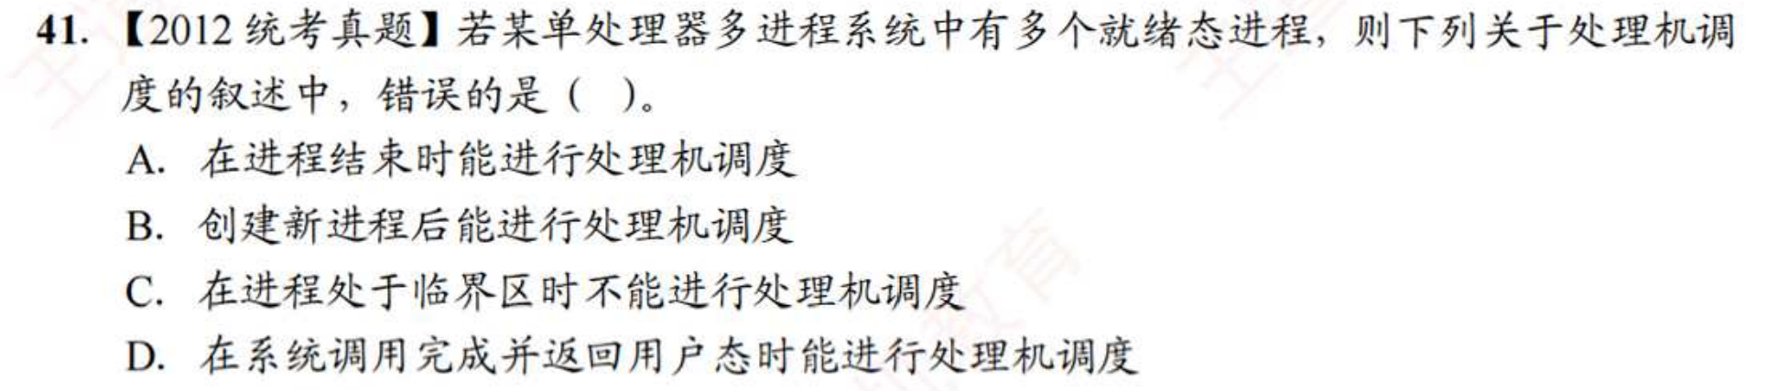
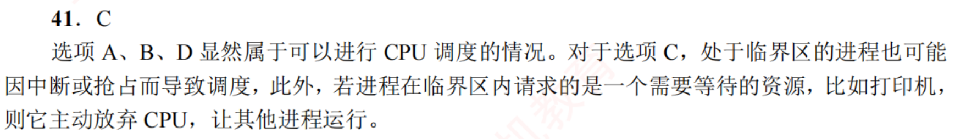
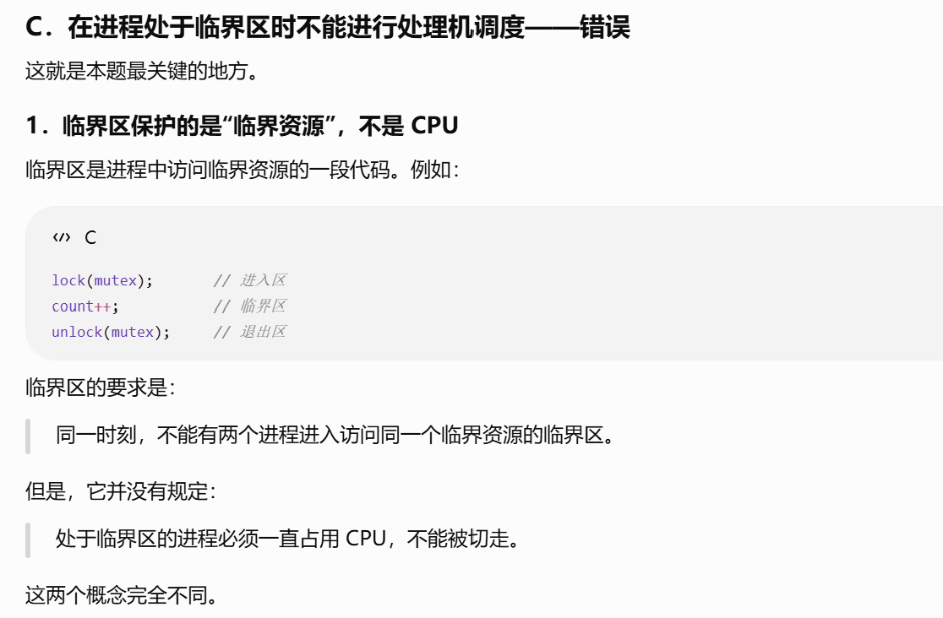

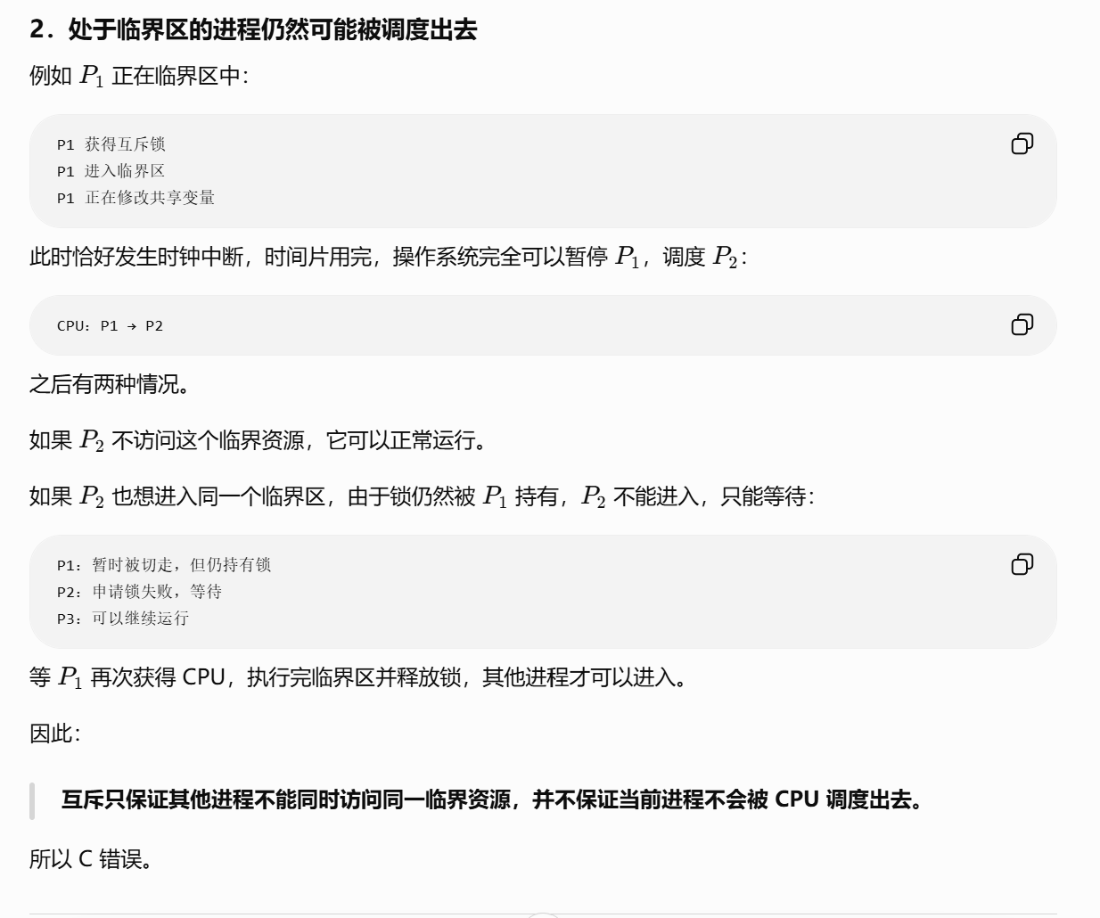
https://chatgpt.com/g/g-p-6a4147b6a8088191bef869eb87bbe5c0-cao-zuo-xi-tong/c/6a5e244c-53a4-83e8-830a-5d39bf79b222

题9：
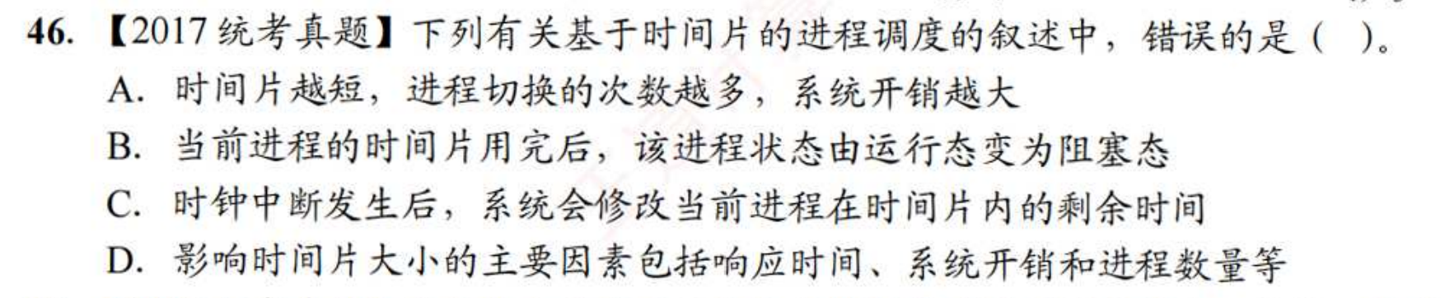
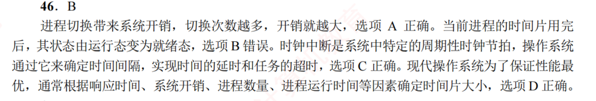
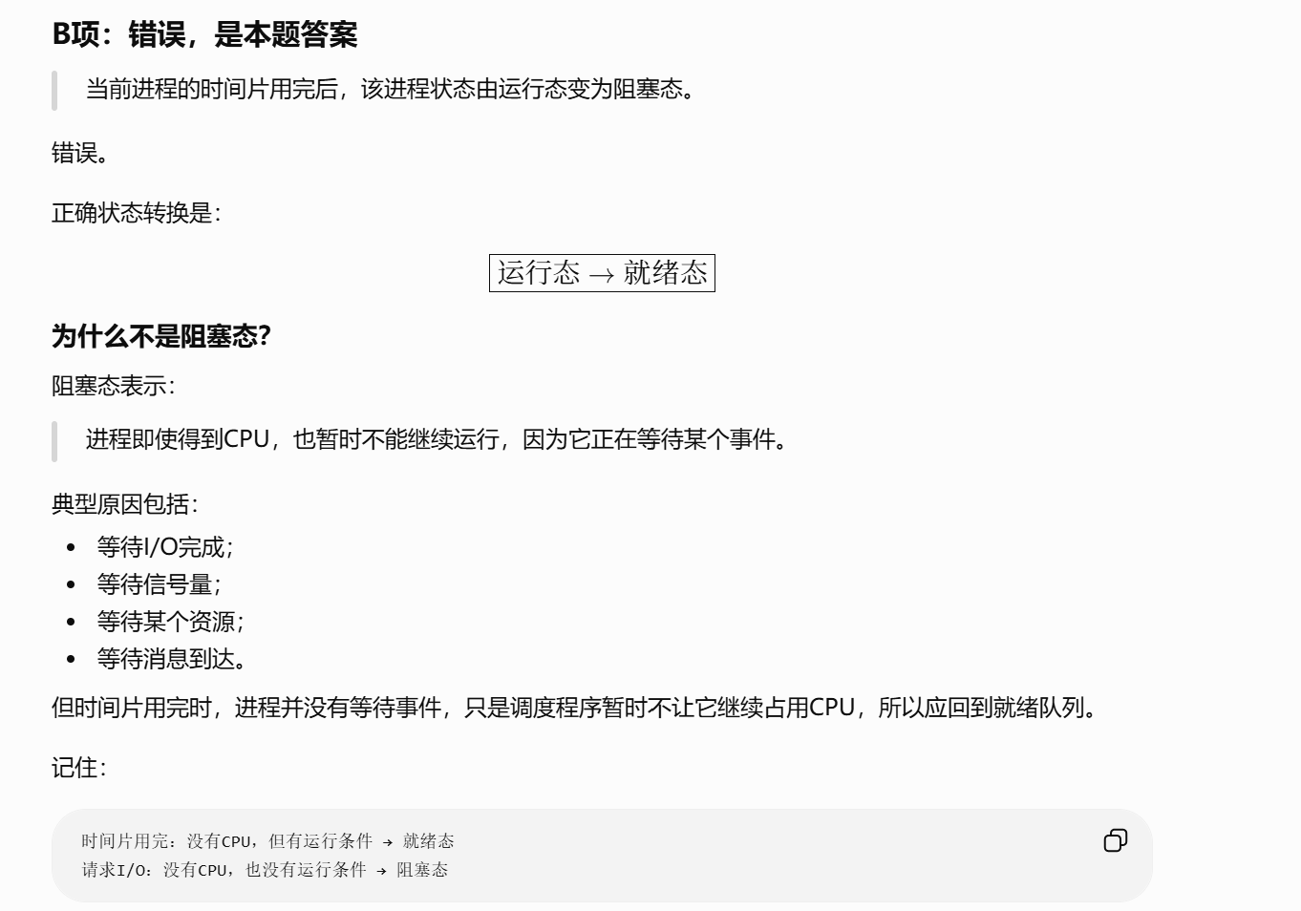
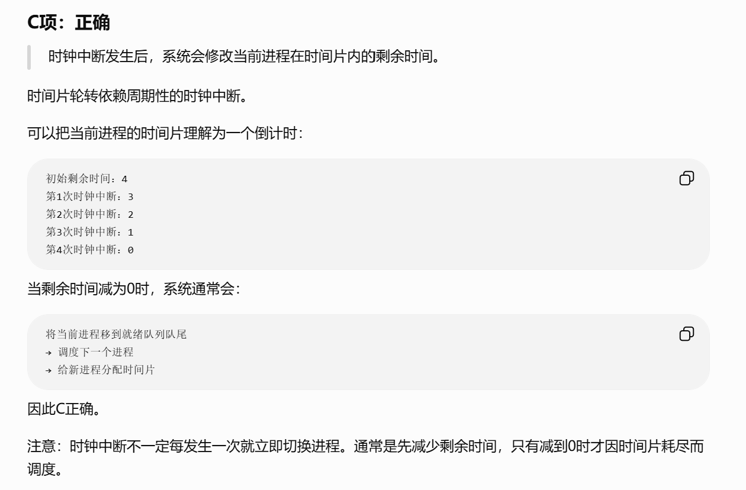

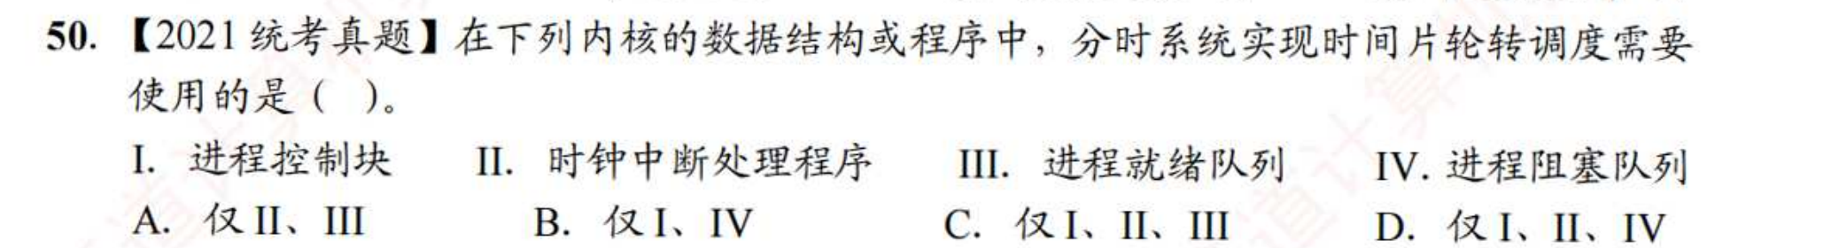
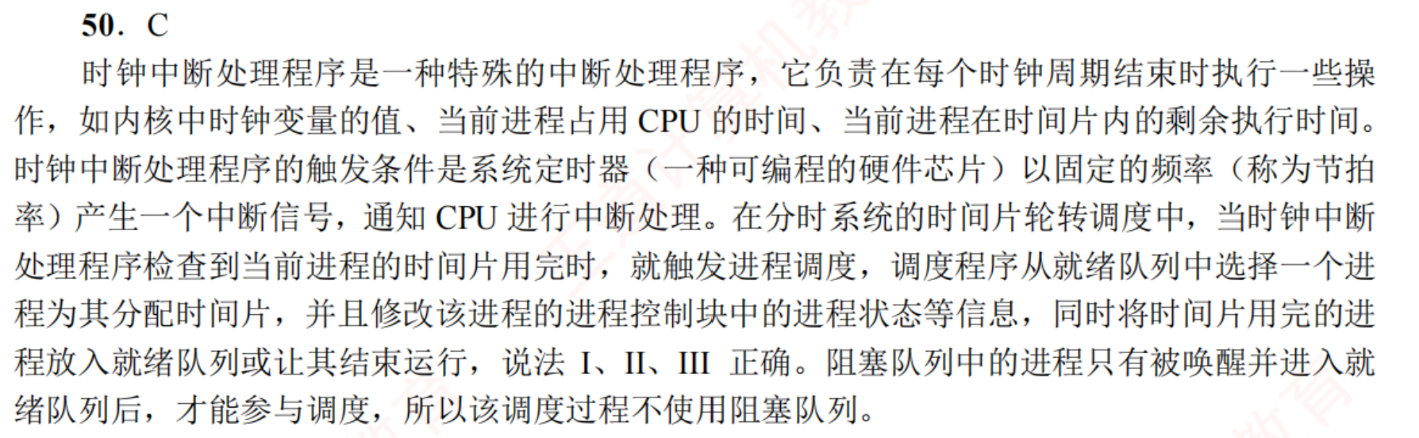
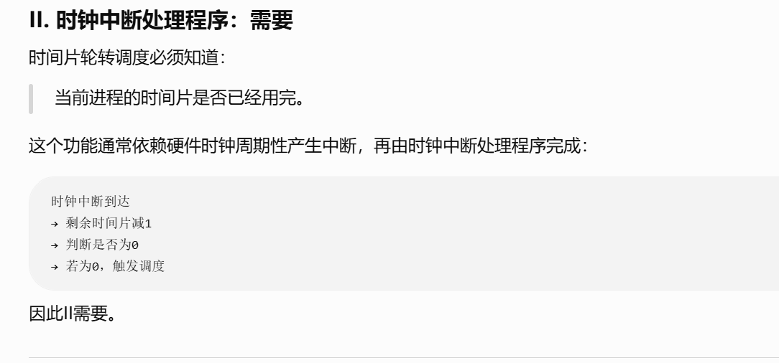
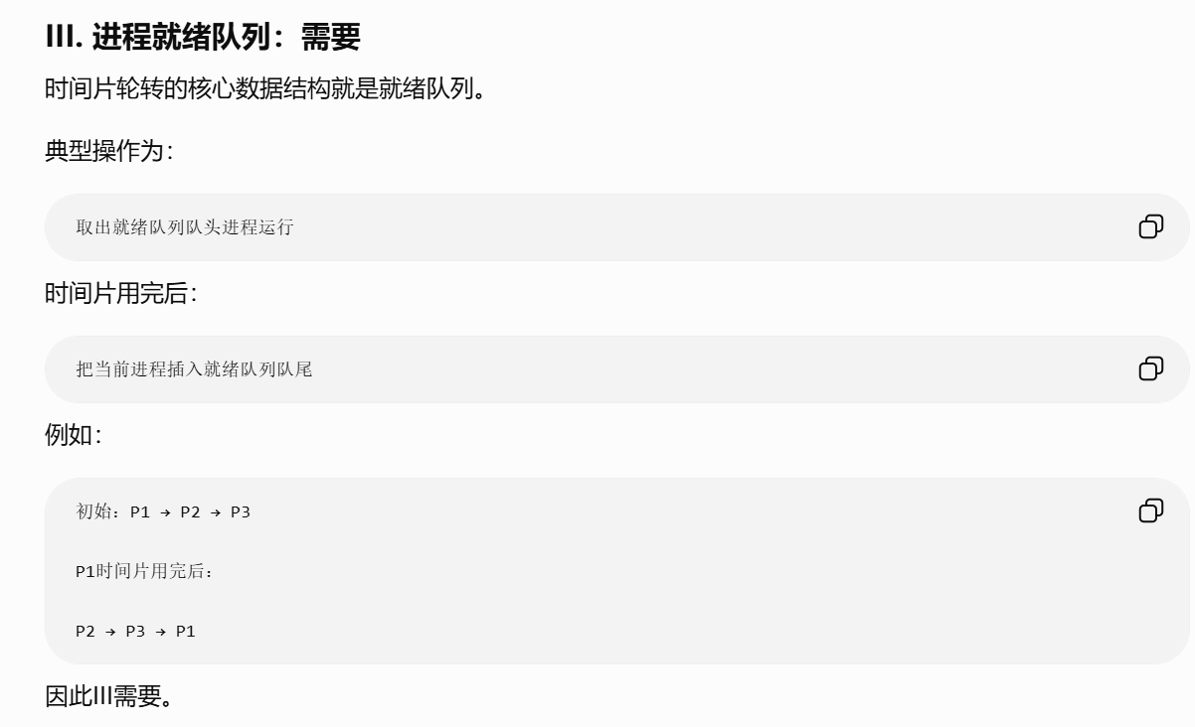
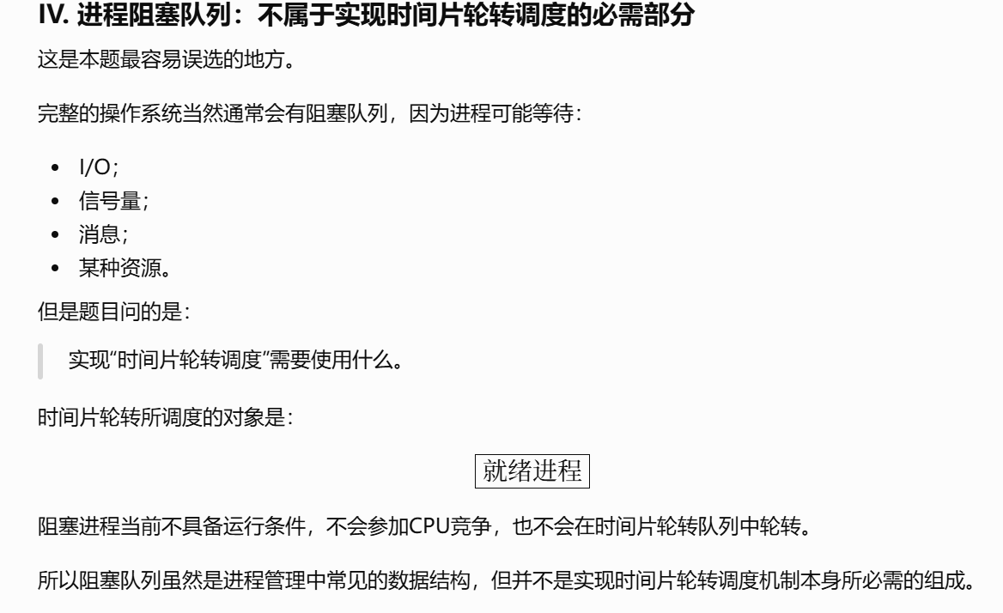
https://chatgpt.com/g/g-p-6a12cc2d8d548191860527308d8d6495-shu-ju-jie-gou/c/6a5e248b-cc20-83e8-8c31-b8d5fa8b09f2

题10：
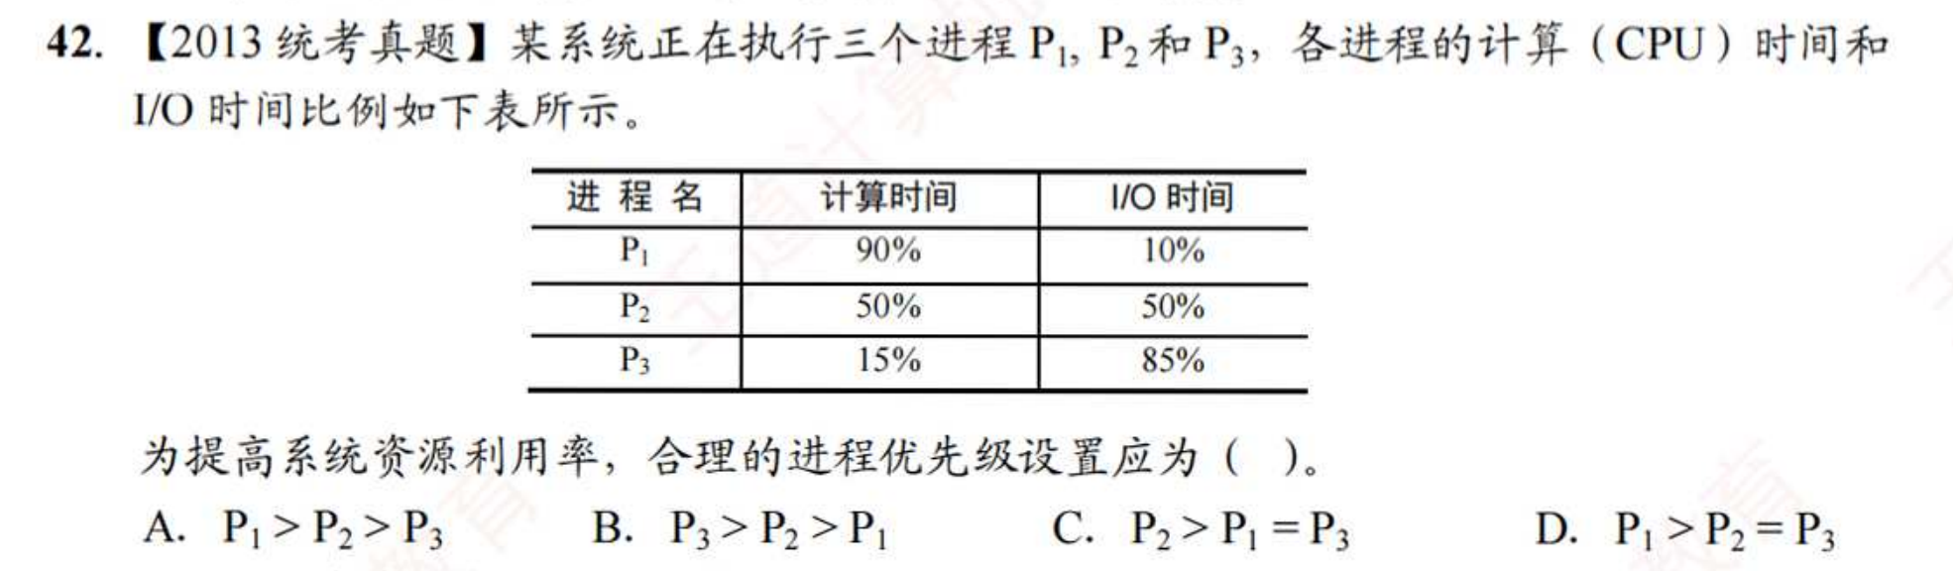
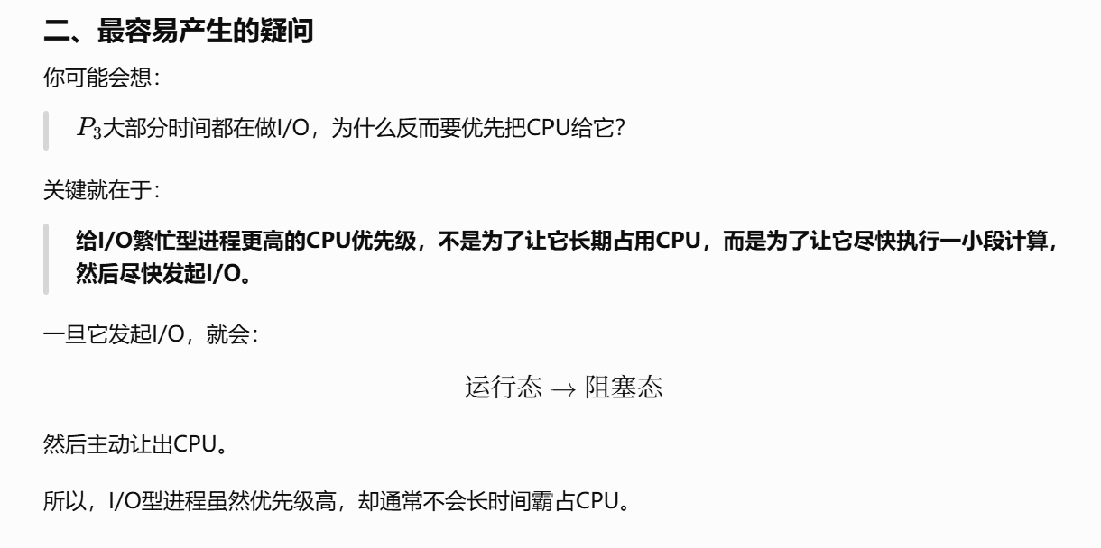
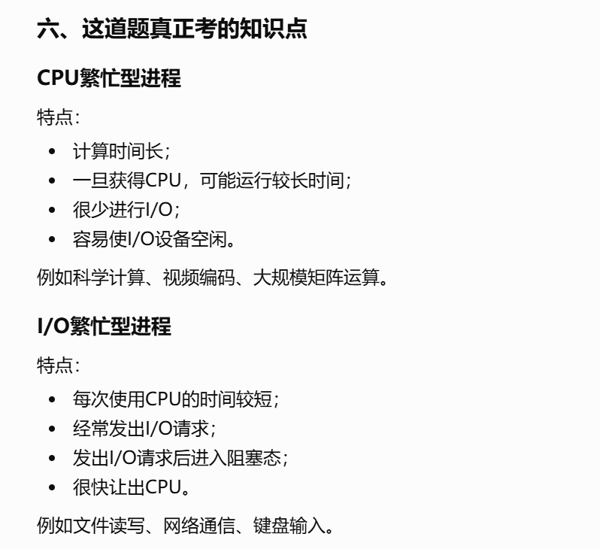
https://chatgpt.com/g/g-p-6a4147b6a8088191bef869eb87bbe5c0-cao-zuo-xi-tong/c/6a5e2523-d26c-83ee-bfaa-af1ac9214e7b

题11：
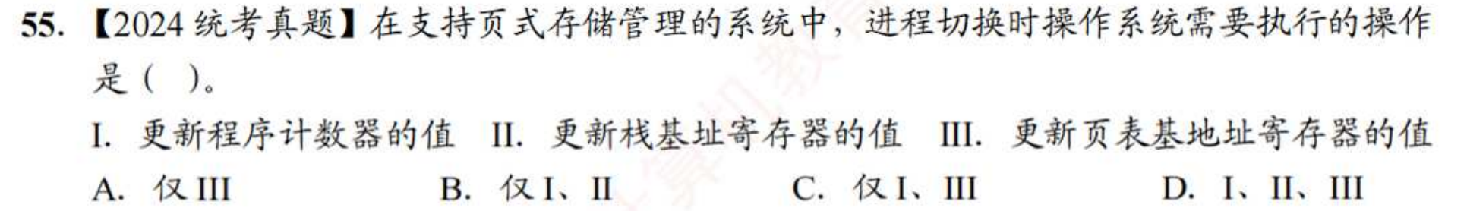
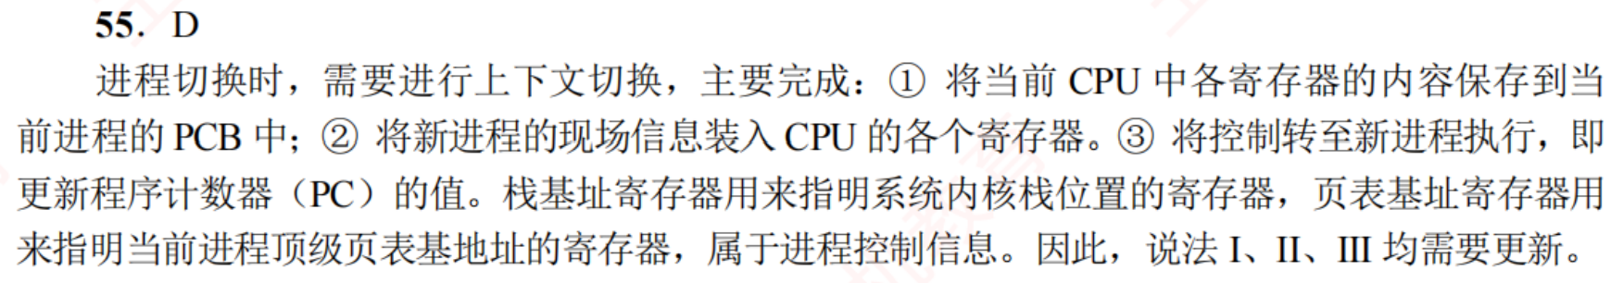
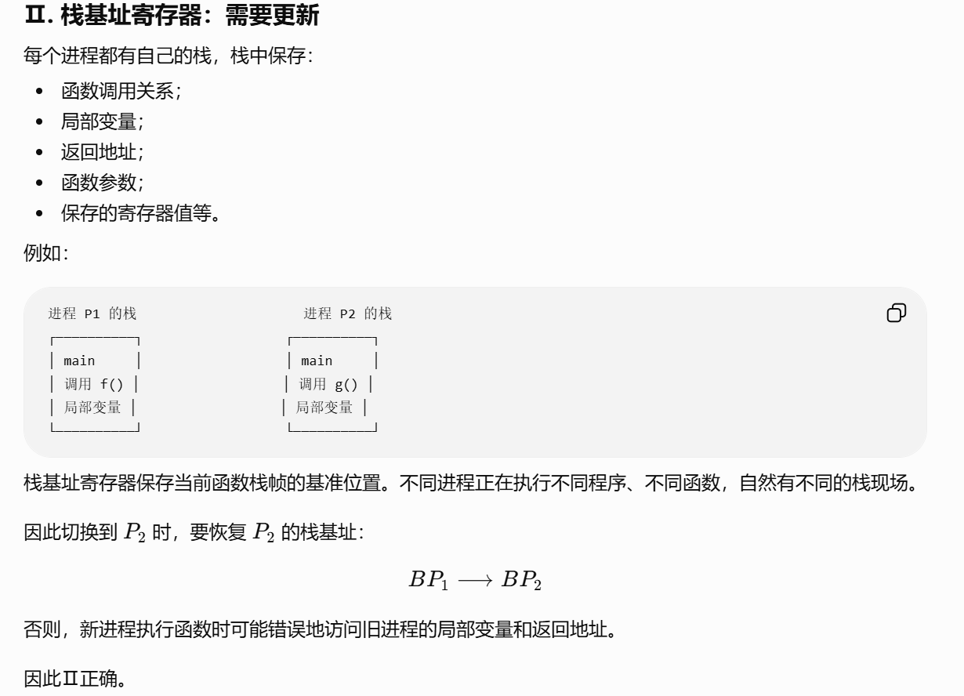
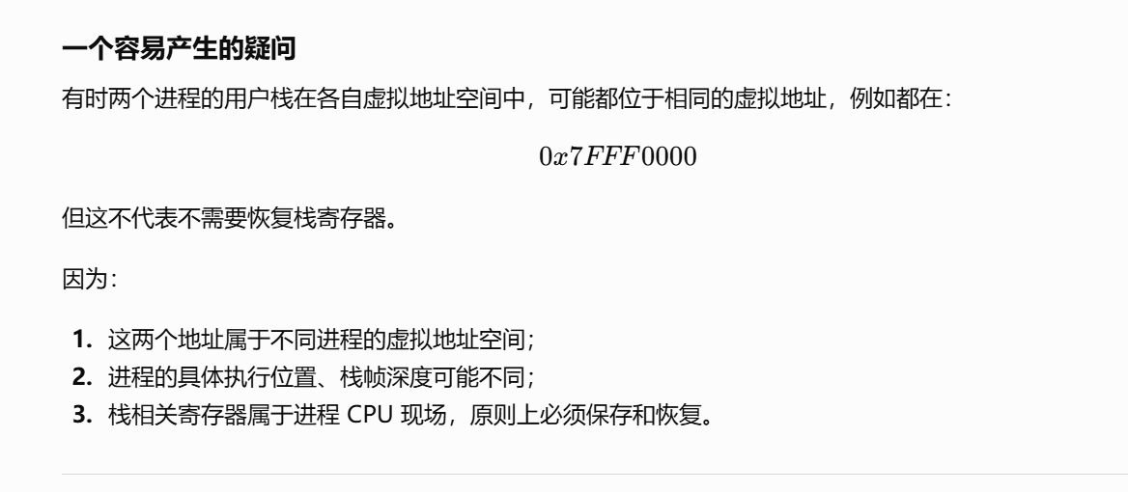

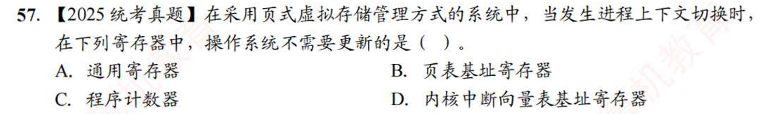
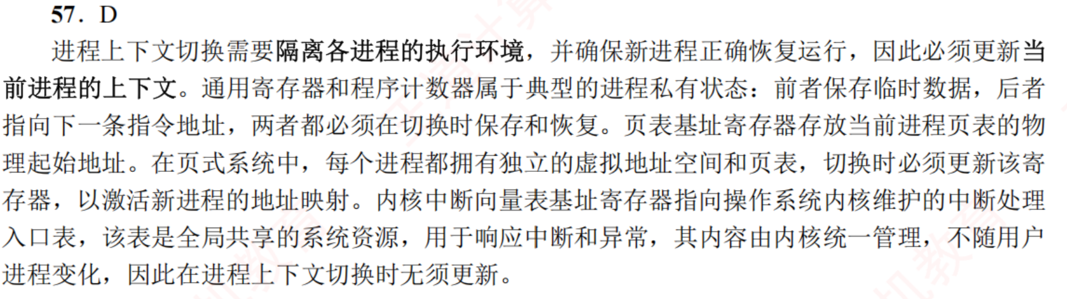
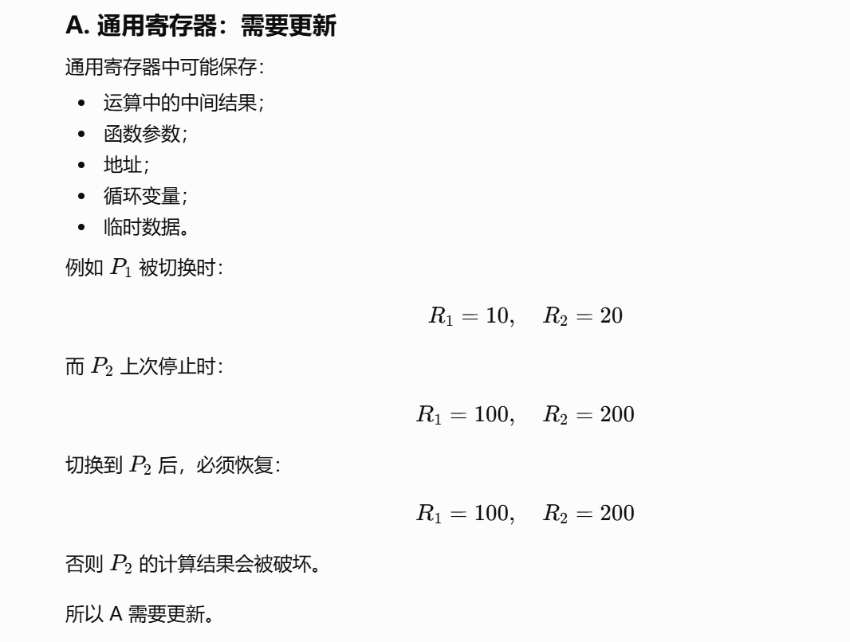
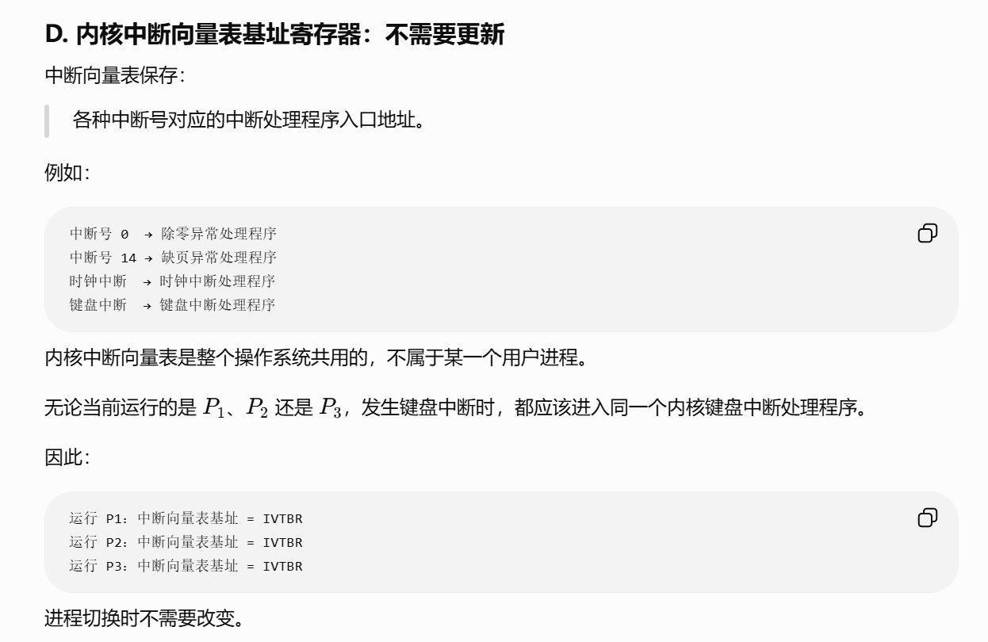
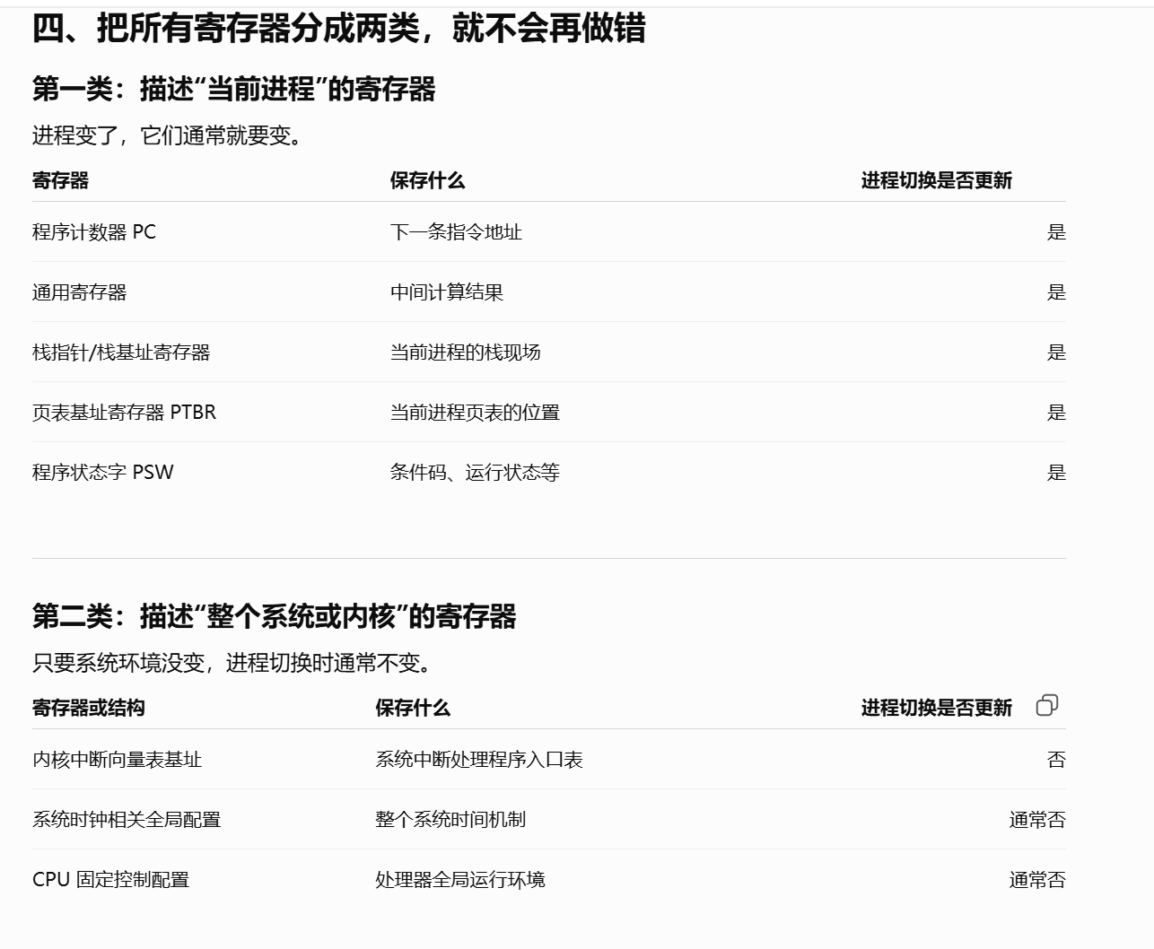
https://chatgpt.com/g/g-p-6a4147b6a8088191bef869eb87bbe5c0-cao-zuo-xi-tong/c/6a5e2856-d3f4-83e8-a783-64df913be85f
|（注：部分内容可能由 AI 生成）

